1. **BACKGROUND INFORMATION**
   1. **EXECUTIVE SUMMARY**

**Introduction of the organization**

Harare Polytechinic College is a technical college located in the [Midlands Province](https://en.wikipedia.org/wiki/Midlands_Province), [Zimbabwe](https://en.wikipedia.org/wiki/Zimbabwe) it falls under the Ministry of Higher and Tertiary Education, Science and Technology Development. Harare Polytechinic is one of Zimbabwe's distinguished and vibrant technical colleges. It offers over 60 conventional courses ranging from National Certificates to National Diplomas and Higher National Diplomas. It is located just about three kilometers outside the Gweru city center towards Harare along the Harare road.

Harare Polytechinic evolved from a satellite college of the Bulawayo Technical College that had been established at Chaplin High School in Gweru before the country’s independence in 1980. The Satellite College was converted to a fully-fledged technical college after independence. A critical shortage of lecturers for technical colleges was experienced the country soon after independence. The government of Zimbabwe then commissioned a study on the training of lecturers and upgrading of skills of those already employed by technical colleges. Harare Polytechnic was given a mandate to train lecturers for other technical colleges and the first intake of these “cadet lecturers” was in 1986.

Its focus is to produce quality technical education and training for industry and commerce in Zimbabwe. The College offers courses in a variety of fields that is business, engineering, mechanical, electrical, education and information technology. The principal is the head of the college and is commissioned by the government to run all the college affairs on behalf of the government. The Principal is assisted by the Vice Principal and Accountant in the execution of his duties. To make their goal of producing quality graduates achievable the principal is backed by the Heads of Divisions (HODs), who also have the Heads of Departments (HODept), Lecturers in charge and lecturers to assist them.

**Mission statement**

Harare Polytechnic is committed to offering quality technical and vocational education and training focusing on the production and development of patriotic lectures, teachers, training officers, instructors and skilled personnel for public and private institutions.

**Main objective and functions of the organisation**

* + To produce healthy, skilled and patriotic personnel
  + To promote research and technological developments
  + To produce entrepreneurs
  + To commercialize products and services
  + To develop, produce and provide teaching/learning materials
  + Developing and implementing an effective science and Technology policy at the polytechnic
  + Creating conducive training and learning environment.
  + To develop committed and patriotic Zimbabweans for national development

Introduction of technical and vocational Education Programme

**Company Vision**

To be the leader in the provision of quality technical education and training for the education sector, industry and commerce in Zimbabwe.

**Company goal**

To ensure that public and private institutions are manned by healthy highly skilled and patriotic personnel to satisfy the demands of the local and national community.

**ORGANISATIONAL STRUCTURE**

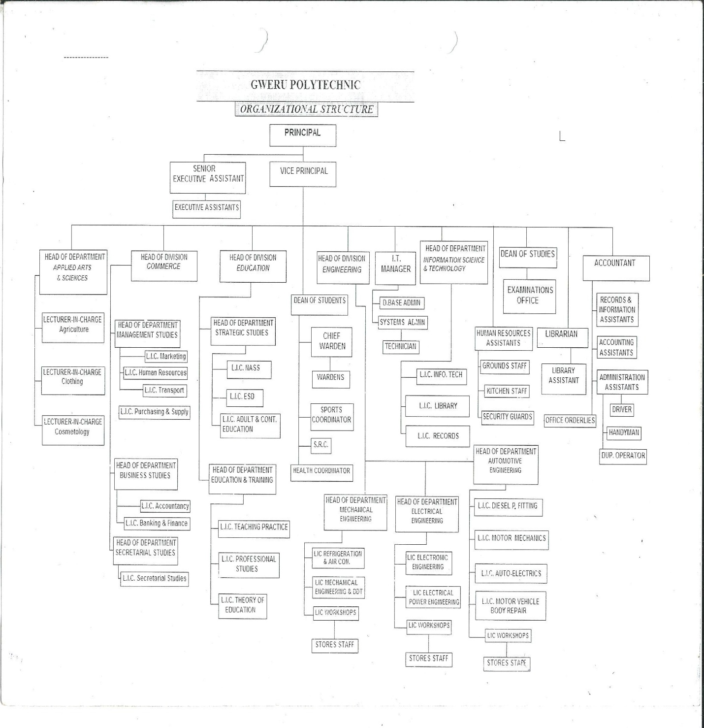

**Key For the Organizational Chart**

**I.T**-Information Technology

**L.I.C -** Lecturer in Charge

**S.R.C**- Student Representative Council

**Organizations’ line of business**

Harare Polytechnic is a fast growing institution that aims to produce healthy, highly skilled and patriotic personnel who satisfy the demands of the community. Its focus is to produce quality technical education and training for industry and commerce in Zimbabwe. The Polytechnic is home to a diverse population of students from within Zimbabwe and from neighboring countries such as Namibia, Botswana and South Africa among other countries. The Division of Students Affairs is responsible for the holistic development of all students by addressing various aspects of their social wellbeing and skills development relevant to the student population. The Division’s core functions include training and development of student leadership, co-ordination of student life events, supporting student governance structures such as the Student Representative Council (SRC) and guidance and counseling. The Division responds to any query that students and parents bring and other stakeholders are encouraged to contact the Division at any time in the interest of their education.

Its priorities involve ensuring a quality learning experience for all learners through providing adequate and appropriate academic support to learners, enabling them to realize their full potential. The Division is needs-driven aiming to enhance student success by identifying and addressing social problems which include trauma, abortion, unintended pregnancy, substance abuse etc. Campus life at Harare Polytechnic is equipped with social clubs such as Christian Union, Debate Association, Retract Club and Health and Life Skills Committee which provide a much needed support system for students.

**Introduction of the system to be studied**

The system to be studied is called Asset Management System and it is centred on the IT Unit which is the heart of the college in terms of technology. The system’s main aim is to track organizational assets from the day they are received from the supplier and where they will be located. This wills in turn help to provide an effective record management system which provides accurate data at required times. The system will be used by the Information technology department aiming to record and control incoming assets at the same time monitoring those assets which are already in the organization.

**Aims of the system/functions the system is intended to do**

* The proposed system will capture data and view all the assets in the college and their location.
* The system will improve efficiency and effectiveness by using computers, printers and this will also help to increase production, speed and accuracy.
* The system will be able to show the status of assets in the whole college that is whether they are working or not working.
* This system is going to store records in a database that will reduce the need for space for filing cabinets.
* The system will output essential equipment reports whenever they are in need.

**Scope of the project**

Information technology has become widely used at Harare Polytechinical College; this has resulted in the vast increase in the acquiring of IT inventory which includes printers, computers, switches, network routers amongst others. The system is basically centred on the I.T department of the entire college. Tracking of IT inventory in terms of the location, current state, value and details that are essential has become a great challenge since some inventory may not be located and others may be stolen.

The college is comprised of many departments which make use of IT resources, resources can be shifted from one department to the other without being recorded, leading to resources being not managed effectively and this resulted to the researcher to come up with the idea of developing an IT Asset Management System.

This is to improve efficiency and effectiveness through the use of computers, printers and other peripherals taking merit of their speed, accuracy, reliability and cost effectiveness. The system fits in all colleges.

The college comprises of five divisions which are Commerce, Engineering, National And Strategic Studies, Education, and Applied Sciences. Information Technology falls under the Applied Sciences division. Each division has a Head of Department and Lecturer in Charge and those people have their own set of computer which needs to be serviced and it’s the duty of IT department to take care of them.

* 1. **PROBLEM DEFINATION**

It is best to discuss in brief the problems of the existing system before getting into the objective and scope of the system. The present system is file based which deals with everything pertaining the management of assets in the whole organization.

**The negative effects of having a manual system for data capturing and the disadvantages associated with this current system can be briefly analyzed below:**

Harare Polytechinic do most of its processes manually, and its time consuming. Assets are registered manually, and this takes time as the information is recorded in different files and there will be data redundancy. The relationship among the subsystems is not well defined in this current system.

The spreadsheet does not offer strong security measures to stored data. The use of a manual system has often leaded to redundancy. Also suppliers are claiming payments of services that they have not offered.

The manual system is very tedious to use during the auditing of asset management book by external auditors**.** The present system is prone to fraudulent activities as all the information recorded is done on papers. Information can be tempered with whereby anyone can edit asset details without seeking permission to the IT manager.

Stationery wise the file system is very expensive. Recording of all incoming assets requires stationery and carbon papers for backup facility.

Labor intensive- Storing the records manually requires consistence in maintaining the files well kept and sorted. Quick retrieval also needs a lot of labour for it to be effective.

The manual system is not secure since there is use of cabinets to store the files, even back up is not there in terms of theft or fire but the proposed system will offer external dives for backup measures. Computers have a larger memory storage and there will be introduced a centralized database whereby information will be found at one place making life easier for everyone who will be using the system.

The system cannot automatically detect those machines which are not working or obsolete pointing it to be ineffective.

* 1. **TERMS OF REFERENCE**
* Identification of areas of concern in the current system.
* To analyze the how to secure existing system.
* To investigate the weakness of the current system on inventory management.
* To develop an effective inventory management system.
* To demonstrate the ability of inventory management system in managing IT stock.
* To critically analyze each of the alternatives so as to select the most preferred solution to the current system's deficiencies.
* To maintain a comprehensive database of information on all details including assets, suppliers, asset location and date received.
* Reduce human errors thereby reducing data redundancy.
* To produce documentation for the system developed from the feasibility report, requirements analysis and design specification documents.

# 

# Objectives

* Provide an effective record management system which provides accurate data at required times.

#### The system should be able to provide an automated and user-friendly mechanism that will enhance the efficiency of query handling.

* The system should be able to keep track of supplied assets specifications to include products supplied and their specifications.
* The system should be able to provide timely and accurate information and reports that helps in speedy and quality decision making.
* Increase security by limiting access to the system by the use of usernames and passwords.
* To maintain an updated database that shows the current information about the equipment within the organization.

**Hypothesis**

This new system to be introduced will require:

* **Microsoft Visual Studio 2010** - a flexible, new and simple Rapid Application Development tool that results in a rich Graphical User Interface.
* **MySQL Server** – a scalable and robust Relational Database System.

**Justification**

The proposed system will effectively solve the challenges faced by Harare Polytechinic IT department such as improving accountability of procured assets and effective tracking and management of the company resources. The Visual studio package will provide a user friendly interface of forms that will be used to input data.

The proposed system is also justified as it is going to use a database management system which will provide a security system which will prevent unauthorized access and maintain data integrity to stored data.

Data redundancy is reduced because of the use of a relational database.

Paperwork is reduced. Thus saves cash in terms of stationery.

Errors or omissions will be removed, as the system will not allow for blank fields.

* 1. **FEASIBILITY STUDY**

This is quite a crucial stage in the systems analysis and design phase, the stage seek to determine whether a solution of computerization is a best solution to the current problems at hand. It is well understood that in order to ascertain whether it is worthwhile to articulate the project within the budgeted time, and business fraternity. It also reveals important risks associated with the project while answering the following questions:

1. Can the system be built?
2. What is the criterion for scoring success?

**Technical feasibility**

Technical feasibility is performed in order to assess whether the current system is technically feasible to support the project in term of hardware, software and technical expertise. Technical Feasibility is inclined on the technical expertise and the availability of the equipment to be used.

**Technical Expertise**

In this case we are trying to establish whether the system engineer(s) involved in the project are fully technically competent to produce the specified product. The success of the developments needs at least the skills of a single Vb. net and MySQL server. The developer of the system is very familiar with the above mentioned software tools needed to develop the system. And to ensure continuity a back up developer is available to fill in for the appointed developer in the form of one of Harare Polytechinic’s Administrators. This appointment is to be treated with a very high priority and enforced as a mandatory requirement. This is done not only to necessity continuity in cases of emergency, but also to provide some training to some in house IT staff, eventually equipping them with skills to sufficiently support and customize the system appropriately when the need arises.

**Hardware Requirements:**

A computer system with the following specifications:

* **Processor:** Intel dual core or above
* **Processor Speed:** 2.5GHZ or above
* **RAM:** 2 GB RAM or above
* **Hard Disk:** 250 GB hard disk or above
* HP LaserJet color printer

**Software requirements:**

* **Language:** Microsoft Visual Studio 2010
* **Database:** Microsoft SQL server 2008
* ESET SMART SECURITY (latest version)

## General Non-Functional Requirements

Constraints associated with the development of the system include:

* The system should respond to queries presented to it by the end-users.
* The database should not be vulnerable to the end-users. It should not be accessible to them at all. Therefore, there should be an operating environment for system developers and an operating environment for system users.
* The system should allow for use of password security. Only authorized users, with a recognized sign-on and confidential password should have access to the system.
* Each individual should have a unique sign-on, which should designate the level of access required.

1. User level
2. Operation levels (add, change).
3. Application level.

* The system should allow for alterations to be made easily to its capabilities.
* The system should make use of user familiar terms.
* The system should be consistent in its operation.
* The system user interface should provide a meaningful feedback when errors occur and provide content sensitive user help facilities.
* The interface should provide appropriate interaction facilities from different types of system users.
* Provide for required changes to user passwords based on specified period of time.

**Challenges encountered**

* The need to have the wholehearted cooperation of the potential users. Some users would feel job insecurity due to computerization.
* The need to be familiar with the application domain and this includes being well versed with the terminology of the organization or department.
* Those who possess the required information should be willing and able to spare time to elicit the information.

These challenges were solved by the programmer’s ability to be flexible, objectivity and negotiating skills.

**Skilled Manpower:**

* Developers should have adequate experience and skill in working with Visual Studio and MySQL applications. They should develop a user- friendly system, which offers polite messages to the users.
* The system’s users should also be technical so that they are easy to train and thus be effective in using the system with minimum drawbacks.

**Operational feasibility**

The main objective for performing operational feasibility is to establish the urgency of the problem as well as the acceptability of the proposed solution by its end users. In order to achieve this I interviewed the helpdesk staff/assistants, hardware personnel, and the infrastructure and communication division manager to ascertain the problems caused by using the current old manual system which is now obsolete and causes economical risks to workers. At the end of the day we realized that:

* Incomplete information of assets exist after the distribution of new acquisitions
* There is no proper record of past trends
* It is difficult to produce relevant reports on time
* Duplication of work exists
* Less security rules leading to theft and disappearance of some machines.

Having established that, l explained the proposed system and gave an abstract overview of how it is going to solve some of the identified problems time getting feedback about this idea. We found out that the help desk assistants and the hardware personnel feel that it is necessary to have a formal up to date computerized system. Most of those presented with the idea were pleased that something finally was going to materialize though some were skeptic about the proposed system being locally developed.

**Overview of the Operational Feasibility**

Having established that the current system have a lot of issues that need to be addressed and the fact that both management and staff feel that the system needs to be replaced. I conclude that the project is operationally feasible.

# Social feasibility

* There will be training of all the systems users before the system is implemented so that they will not resist introduction of the system.
* User manuals will be prepared to the end-users. This will contain information that guide users in how to use the new system, thus making them feel comfortable in working with the system.
* Motivational skills are going to be used when the system is implemented

**Economic feasibility**

This tries to establish whether the project can be successfully completed within the budget constraint set. And to establish whether the project is going to be feasible in that regard steering committee is going to use the payback analysis to assess how long is it going to take the project to start for itself or making some positive inflows against the initial developments costs.

|  |  |  |  |
| --- | --- | --- | --- |
| **YEAR ►** | **2015** | **2016** | **2017** |
| **Benefits** | **$(US)** | **$(US)** | **$(US)** |
| Goodwill | **3000** | **35 00** | **40 00** |
| Estimated services in figures | **10 00** | **10 00** | **40 00** |
| Reduced Paperwork | **5 000** | **5 000** | **20 000** |
| **Total Benefits** | 45 00 | 50 00 | 100 000 |
| **Development Costs** |  |  |  |
| Labor (technical) | 5 00 | 0 | 0 |
| Software Licenses | 4 00 | 0 | 0 |
| Additional Hardware | 5 00 | 0 | 0 |
| User Training | 100 | 0 | 0 |
| **Total Developmental Costs** | **15 00** | **0** | **0** |
| **Operational Costs** |  |  |  |
| H/W Maintenance | 40 00 | 4 00 | 2 00 |
| S/W Maintenance | 30 00 | 4 00 | 5 50 |
| Stationary | 15 00 | 6 00 | 9 00 |
| Other Costs | 15 00 | 7 00 | 10 00 |
| **Total** | **95 00** | **21 00** | **26 50** |
| **Total Costs** | **75 00** | **21 00** | **26 50** |
| **Total Benefits** | **45 00** | **50 00** | **100 00** |
| **Profit/Loss** | **(5 00)** | **29 00** | **73 500** |

The proposed Asset Management System saves money that would otherwise be wasted on lost productivity. Saving time by solving problems in good time will result in increased productivity thereby increasing overall returns for the college.

|  |  |
| --- | --- |
| **Year** | **Project (US$)** |
| 0 | -750 |
| 1 | 450 |
| 2 | 500 |
| 3 | 1000 |

a) **Net Profit = Total Benefits – Total Costs**

= (450 + 500 + 1000) – 750

= US$1200

b) **Payback Period:**

To recover US**$750** which is the initial investment amount, it will take Total Amount of Year 1 which is US450 + 8/12 (US$500) = US$ 783.3. This would take 1Year and 8Months.

c) **Return on Investment = Average Annual Profit x 100%**

**Total Investment**

Total Annual Profit = $1950 - $750

= $1200

Total Average Annual Profit = $1200 / 3

=$400

Therefore Return On Investment = 400 x 100%

750

**=** 53.3%

d) **Net Present Value based on a discount factor of 50%:**

Discount Factor = 1/ (1+ r) ^ t;

where r = Discount rate and t = time

Present Value = Value in Year x Discount Factor

Net Present Value = Total of Present Value

|  |  |  |  |
| --- | --- | --- | --- |
| **Year** | **Value in Year ($US)** | **Discount Factor** | **Present Value ($US)** |
| 0 | -750 | 1 | -750 |
| 1 | 450 | 0.6667 | 30.0015 |
| 2 | 500 | 0.4444 | 22.220 |
| 3 | 1000 | 0.2963 | 29.630 |
| **Net Present Value** |  |  | **6.852** |

**Overview of Economic Feasibility**

**Working within the Budgetary Allocations, and being able to pay itself back within the anticipated time framework, steering committee concludes that the project is economically feasible and recommends the payback method to be used.**

**Risk analysis**

As with other project there are risks involved. And in the following section steering committee is going to identify the serious risks, estimate their likelihood of occurring, and assess them and to come up with ways to avert these risks and monitor all circumstances that may lead to the risks. Risk management is very critical because if ignored and these risks do happen they can delay the project, increase the project costs or even worse cause the project to be abandoned

**Technical Risks**

For users to be able to use the visual studio system they should be able to understand and comprehend the system be user friendly otherwise they will not be able to utilize the system. To counter this risk, to the users of the proposed system they have to be first trained so that they familiarize with the system. From the developers point of view they are familiar with the tools to be used in the development of the proposed system therefore they will not be any technical risks to be faced

**Economic Risks**

Currently with the coming in of the new inclusive the people are waiting in anticipation that may be the foreign currency shortages may be alleviated otherwise if the crisis continues i.e. the scarcity of foreign currency costs will continue to escalate and the project risk being terminated. The main problem centers upon the availability of this scarce forex that is needed to import the software and hardware triggered by current credit crunch market conditions.

To counter this risk of terminating the project due to scarce foreign currency, engaging the donor world who are ready to support the operations of the organization would make the solution.

**Low Confidence in Developer/ Quality assurance**

The Zimbabwean IT industry is perceived as immature, and this has resulted in locally developed products before being under rated. Before the discovery of the internet theses fears were justified but the advert of the internet. It practitioners in Zimbabwe are now equally equipped in terms of know how making these fears baseless. To make matters worse the assigned developer is perceived as inexperienced.

The best way to ensure that the risk is not realized is:

* To appoint an external Quality assurance officer to review the quality of the system as well as to allow the users to assess whether the product is up to their expectations
* To ensure that the developer has access to the internet to ensure the continuous availability of information
* Stakeholders identified as lacking confidence should be educated about the developments in the IT industry in Zimbabwe

**Management** – should the risk become reality, an experienced Visual Programmer /Project Manager should be recruited to provide the needed assistance. This should act to establish some confidence in the project.

**Tight Schedule**

In their eagerness to implement their new technology driven strategy, the college has demanded a very tight schedule of 8 months. This could result in undesired pressure on the developer making her produce a sub standard product as she could end up not implementing all the desired functionalities in her efforts to meet the deadline

To avoid this risk the developer should at all time remain focused on the work at hand

**Other Risks**

Users are unwilling to contribute towards the development of new computerized system. This unwillingness is caused by resisting the new way of asset management when the new system is introduced. However, we informed users that their cooperation is greatly essential and the benefits brought by implementing the proposed system.

**2. ANALYSIS OF THE CURRENT SYSTEM**

Currently Harare Polytechinic is using a manual asset management system. This system has been used since the establishment of the college in the year 1980. The manual system’s main advantage is that information is not affected in the event of power cuts or failures.

**2.1. FACT FINDING TECHNIQUES**

During the research the following data gathering techniques were used:

* Interviews
* Questionnaires
* Record inspection

**Interviews**

Some of the members of staff, specifically those in departments that interact with the system were interviewed and asked questions pertaining to the current system’s efficiency and effectiveness and areas which needed improvements. The IT manager, technicians and some selected individuals were chosen to be interviewed in order to get a balanced and clearer picture of the current system’s operation, merits or shortcomings as well as new requirements first hand from the system users. The interviews were conducted face to face as well as over the telephone.

The analyst employed both open and close ended questions in order to get as much information as possible from the interviewees. Some of the questions asked were to get some of the technicalities of procedures and processes associated with the current system’s operations.

* **To the Accountant:**

**How do you register supplier, product and stock details in your system?**

**------------------------------------------------------------------------------------------------------------------------------------------------------------------------------------------------------------------------------------------**

* **To the Information Technology Manager:**

**Is the system effective and efficient in registering data?**

**----------------------------------------------------------------------------------------------------**

**How reliable is the security of the current system?**

**---------------------------------------------------------------------------------------------------**

**Have you ever used another system other than the current system?**

**---------------------------------------------------------------------------------------------------**

**What do you think should be done to come up with the system that will reduce the problems you are facing right currently?**

**Advantages obtained**

* Interviews allow first hand information to be gathered since they are done on a face-to-face basis.
* They allow direct communication with the people who interact with the system hence produce a lot of valuable first-hand information such as how the current system works and the associated problems which made it possible to clarify misconceptions about the current system.
* Users were able to stress points on those areas that they thought were critical
* Interviews gave me an opportunity to complement and verify the information that I gathered through other fact-finding techniques
* It is more interactive thereby allowing the interviewer to interpret facial expressions and body language.
* It enabled the creation of an effective environment to obtain the right or required data since it was a dialogue.

**Disadvantages**

* Some information could not be disclosed for security reasons.
* Interviews can be costly as they sometimes require travelling to the site or long phone calls and result in a lot of unproductive work time.
* Interviews interrupt the day to day running of the business
* Interviews interrupt the day to day running of the business

**Problems encountered**

Some interviewees were reluctant to give their opinions in detail due to fear of victimization. The whole process of interviewing people affected daily routines. It was a tiresome task interviewing people and too much detail was gathered and was difficult to analyses.

**Questionnaires**

The questionnaires were sent mostly to the members of staff who could not be interviewed since interviews are a bit time consuming and difficult to set up. Questionnaires were designed with a relatively consistent style so that the respondents did not have to read instructions for each question before answering it. Questions which generated interest were placed at the top to grab the respondent’s interest and increase their willingness to participate.

**Why Questionnaires?**

The questionnaires were prepared with the view that they give the college staff the opportunity to complete them on their own free time. The questionnaire prepared was of the following format:

**How does the current asset management system operate? Give a description of its operation**

**---------------------------------------------------------------------------------------------------------------------------------------------------------------------------------------------------------------------------------------------------------------------------------------------------------------------------------------------------------------**

**What are the good aspects about the current system?**

**---------------------------------------------------------------------------------------------------------------------------------------------------------------------------------------------------------------------------------------------------------------------------------------------------------------------------------------------------------------**

**Give the current system deficiencies?**

**---------------------------------------------------------------------------------------------------------------------------------------------------------------------------------------------------------------------------------------------------------------------------------------------------------------------------------------------------------------**

**Are there any modifications that you think are necessary in current system?**

**---------------------------------------------------------------------------------------------------------------------------------------------------------------------------------------------------------------------------------------------------------------------------------------------------------------------------------------------------------------**

**Would you like to computerize your system?**

Yes No

**If yes, which areas would you like computerized?**

**Advantages obtained**

* Questions are easier to arrange as compared to interview questions.
* The respondents had time to consider their responses before writing them down.
* A large amount of information was collected from a large number of people in a short period of time and in a relatively cost effective way.
* Due to the anonymity provided by questionnaires respondents answered the questionnaires more openly and honestly.
* Can be carried out by the researcher or by any person with limited effect to its validity and reliability.

**Disadvantages**

* There was lack of personal communication between the researcher and the respondent leading to biased information to be given.
* Some of the questions were answered wrongly because they had been misinterpreted while others were left unanswered because they seemed ambiguous to the respondent.
* Wrong responses were provided just to impress the researcher or not taking the questionnaire seriously.
* There is no way to tell how truthful a respondent is.
* People read differently into each question and therefore they reply basing on their own interpretation of the question - i.e. what is 'good' to someone may be 'bad' to someone else, therefore there is a level of subjectivity that is not acknowledged.

## 

## Record inspection

The method involves observing physically the records on previous transactions showing payables, receivables, suppliers, orders and students and also any reports that may have been generated using the currently existing system. Record inspection played a crucial role in providing information concerning the operation of the current system. Sample Registration forms that are given to newly enrolled students and the old students who continue with their courses.

* Purchase orders prepared for suppliers
* Files that contained details of products and suppliers
* Business organization chart
* Files that hold company details
* Expenditure reports
* Documents that contain college’s product inventory.

**Advantages**

* It offers first hand information on asset management trends.
* Data is available on the spot.
* Any error that may need attention is noted just in time.

**Disadvantages**

* Chances are high that irrelevant data may be gathered. It is time consuming as all the records and files may need to be inspected.
* There is no one to ask for information or data clarification.
* Some of the information may be outdated.

**EVALUATION OF RECORD INSPECTION**

From all the documents I inspected, I was able to identify weak areas of the system and those areas that needed improvements. I was also able to update the facts collected. Hence, records inspection played a very indispensable role in gathering the required information.

**2.2. CURRENT SYSTEM DESCRIPTION**

This section will give a description of how the current system works, that is; data required by system (inputs), how it is processed and flows within the organization, the information produced by the system (outputs) as well as the people that interact with the system. This data has been collected through the use of a combination of the aforementioned fact finding techniques. After doing an extensive research about the way the current system works, the analyst gained a good insight into how the new system can be developed.

The current system is a manual based system in that all documents and storage is done manually and storage is done in physical storage cabinets. The system flows as follows; suppliers delivers assets to the accounts department then the accountant record the asset in the purchases book and wait for the IT manager to sign indicating that he received the goods. The IT manager is the one responsible for the distribution of assets within the college. If anyone faces challenges with their computers they notify the IT manager and he will see whether the gadget is obsolete or can be repaired and then he will write this in his asset management book with the help of his technicians who are responsible for monitoring the status of all the equipments in the whole organization.

## Business Procedures

## Current system inputs

* Supplier details.
* Product details.
* Invoices from the supplier

Current system processes

* Supplier registration.
* Product registration.
* Process purchases transactions.
* Report compilation.
* Tracking for misplaced assets.

# Current system outputs

* Suppliers and stock lists.
* Periodic Reports.
* Performance reports.

**CLASS DIAGRAM FOR THE CURRENT SYSTEM**

|  |
| --- |
| **SUPPLIER**  Full name: string  Contact details: varchar()  Delivery date: date  Supplier registration  **ASSETS**  Serial number: varchar()  Department: string  Model: string  Status: string  Date received: date  Asset registration  1 has 1…*  1  1..*  1 ...*  1 ..*  **ACCOUNTS**  Supplier name: string  Serial number: varstring  Invoice number: double  Approve/disapprove payments for transactions to be made  **IT DEPARTMENT**  Registration:  Reporting:  Monitoring assets distribution and movement  1 ..* brings many ..* |

**Current system deficiency**

* Since the information age has actually progressed the use of a manual system is now a thing of the past hence the need for developing or purchasing a new system
* The manual filing system is very difficult to respond to queries made by the customers
* The control procedures are not effective and the system cannot track the machines especially those which are transferred from one department to the other and those which are obsolete.
* The manual filing system is very difficult to respond to queries made by the customers
* The current system is time consuming that is services are slow as there is the searching for the asset whenever needed its location or condition.
* There is no security as one can access the files and edit information without anyone’s knowledge and its possible for one person to gain access and pull out a sheet from the files and forget to put it back therefore it results in the misplacing of the important information about the records which were contained in that record.
* The system is very inefficient as it takes time to produce required reports in a specified time frame.
* There are lots of errors and mistakes that are incurred within the current system especially on input of data.
* System is much costly as more stationery is used in the input, storage and output of data.
* The record searching process within the system is very slow and is becoming even slower. This is because of the ever-increasing number of assets which are being acquired by the organization.
* There is no proper backup facility within the current system. This is very dangerous in cases when a disaster like a fire happens.

**Strengths of the current system**

The current inventory system has been in operation for years and the company has been modeled along those lines. Training of the personnel is not a requisite since much of the work is done manually.

The costs of developing and purchasing software and hardware are eliminated. It is not affected by loss of power as every activity is written down in the books manually.

Conclusion

The sole purpose of this phase was to ascertain the goals and objectives of the organization as well as analyze and understand how the current system operates and the problems associated with the system. After identification of problems associated with the current system, the stage also aimed to derive possible solutions to these problems and in the process come up with specifications and/or objectives of the proposed system.

**3. SYSTEM PROPOSAL**

The essence of the Project is to computerize the existing system so as to gear ***HARARE POLYTECHINIC*** for competition and efficiency in service delivery. With that in mind, the proposed solution is going to computerize the appropriate procedures of the current system at the same time embracing the new procedures. At the end of the day, the proposed system will operate as the current system with the following features:

* The updating and modifying of resources lists and details is to be computerized.
* Improve on accountability and query handling of the machines in the IT department thus enhancing efficiency

The new system would be able to produce relevant reports with much easy. The reporting system should support all levels of management.

**Requirements of the system**

* **Hardware Requirements:**
  + **Processor:** Intel dual core or above
  + **Processor Speed:** 2.5GHZ or above
  + **RAM:** 2 GB RAM or above
  + **Hard Disk:** 250 GB hard disk or above
  + HP LaserJet color printer
  + Back up storage- Magnetic Tapes, external drives
* **Software requirements:**

**Language:** Microsoft Visual Studio 2010

**Database:** Microsoft SQL server 2008

Microsoft Access 2003

ESET SMART SECURITY (latest version)

**User requirements**

In order to be able to use the system the user has to:

* Be able to enter correct information in the system.
* Be able to retrieve information from the database.
* Be able to update the database on each and every transaction made.

**Functions of the proposed system**

The system is centered on the I.T department of the entire organization focusing on the recording and monitoring the movement of assets in the whole organization.

The proposed system must be able to perform the following:

* Capturing of equipment details, supplier details and location of the equipments. Thus, the system will produce a consolidated record.
* Keeping track of all stock inventory.
* Should provide instant feedback on enquiries made management.
* Keeping track of all regular suppliers by grouping them together
* Should produce comprehensive and summarized reports pertaining assets statistics by serial number, category, model and state of the asset. Help in searching of information relating to assets, suppliers and location of the assets.
* Keeping track of all movement of assets from the day it is received upto its final destination.
* Adds and removes assets.
* This system is going to store records in a common database that reduces the need for space for filing cabinets.

**DATA FLOW DIAGRAMS**

Diagrammatic representation of the system is very important as it improves the system under development.

**NARRATIVE DESCRIPTION**

DFDs are the tools for examining how data is transformed and manipulated as it passes through various departments of the organization. They show the passage of data through the system disregarding the current departmental structures and administrative control procedures. DFDs show the inputs, processes and outputs to and from the system. They increase in detail as they go up the levels. The levels covered as an aid to system documentation are as follows:

* Context or Zero Level DFD
* First Level DFD
* Second Level DFD

**DFD SYMBOLS**

|  |  |  |
| --- | --- | --- |
| **SYMBOL** | **NAME** | **DESCRIPTION** |
|  | DATA SOURCE  OR DESTINATION | These are external entities in the system’s environment that defines the boundary of the system. |
|  | **PROCESS** | Indicates data transformation from inputs into outputs. A process has a number on top a name below that consist of an active verb which denotes the description of the process. It should have at least one input and one output. |
|  | **DATA STORE** | Most systems store data for later use and these are depicted as open- ended boxes. Data sit there until needed by some part of the system. It could be a tape or disk or file. |

**CONTEXT LEVEL DATA FLOW DIAGRAMS OF ASSET MANAGEMENT SYSTEM**

Supplier

Department

* Returns, Complaints
* Requisitions
* Returns, Complaints
* Returns
* Quotation, Invoices
* Products

**0**

* Assets
* Monitorig

ASSET MANAGEMENT SYSTEM

RETAIL

MANAGEMENT

SYSTEM

* requisitions
* Licence

GOVERNMENT

*Supplier*

These are the sources of the goods to be sold by the system. The system makes some requisitions to the suppliers. The suppliers will produce quotations for the system inresponse to the requisitions made. Being satisfied with the quotations the system would give anorder to the supplier. The supplier will then issue the goods accompanied by an invoicein response to the order. Goods will be returned back to the supplier in case of breakages during transit and wrong goods delivered and they will be regarded as returns in the system.

*Department*

These are the recipients of the goods sold by the sold by the suppliers the department will ake requisitions of achieves to the system and in return the system will offer the required assets which are asked for. It also makes complains pertaining product faults.

*Government*

The system will register to the government. The government will issue a license to the system. The government will also give the regulations that will govern the day-to-day operations and the extent to which the product range is limited

# FIRST LEVEL DATA FLOW DIAGRAM

Stock Details

Quotations, Products

Product File

SUPPLIER

Supplier Details

Product Details

Supplier Details

Department Details

Dpt Details

**1.0**

REGISTRATION

DEPARTMENT

Department File

Supplier code

dpt code

Supplier File

**2.0**

MANAGEMENT

Asset File

**2**

Quotations, Products, Invoices

Requisitions, Orders, Returns

Requisitions, Orders, Returns

Stock Details

Asset Details

Asset File

MANAGEMENT

Returns Details

Returns Details

REGISTRATION

Mgt Details

M4

Mgt File

GOVERNMENT

Management File

Regulations, license

Asset file

**3.0**

New Management

unupdated File

Updates

UPDATING

Returns Details

Mgt File

Updated File

New Supplier

Updates

Supplier File

Supplier Details

Unupdated File Details

Supplier Details

**4.0**

# DETAILED DESCRIPTION OF THE FIRST LEVEL DATA FLOW DIAGRAMS

Reports File

Reports

REPORTING

***1.0 Registration***

Registration records the details of the supplier, asset and the department of designation.

*Supplier details*

Supplier details are needed at registration (name, address, phone number). These details are recorded in the supplier file. The supplier file contains valid supplier details. Such details are important for reporting purposes and for recording products details. The supplier file is created at registration.

***Product details***

The product details (code, serial number, model, category, and department) are stored in the product file, which holds valid product details. This file is created at registration. It contains details of individual products in the college.

***2.0 Management***

It manages the department file, product file and the supplier file. This subsystem accepts the supplier details, departmental requisitions and complaints which will assist in the management of the files. The management details are stored in the Mgt file.

*Supplier*

The management sends a requisition to the registered supplier. In return, the supplier will respond with a quotation, which will guide the management in generating an order. After being provided with an order, the supplier will deliver the goods accompanied by an invoice to the management subsystem. In case of wrong products supplied, it will be returned to the supplier and will be regarded as returns by the management subsystem.

***3.0 Updating***

All the files produced by other subsystems will pass through the updating subsystem for updates except for that one produced by the reporting subsystem. These files include product file, supplier file, department file, , returns file, Mgt file. The updates will be recorded in the updated file.

***4.0Reporting***

All the files produced by registration, management and updating subsystem will pass through the reporting subsystem for reports. These files include product file, supplier file, department file, returns file, Mgt file and updated file. The reports will be recorded in the reports file.

# SECOND LEVEL DFDS OF ASSET MANAGEMENT SYSTEM

## 1.0 REGISTRATION SUBSYSTEM

**1.1**

REGISTER SUPPLIER

Supplier Details

SUPPLIER

Supplier Details

Supplier File

**1.2**

REGISTERPRODUCTS

Supplier Details

Product Details

Goods File

Department Details

**1.3**

REGISTER DEPARTMENT

Department Details

DEPARTMENT

Department File

## 1.0 REGISTRATION SUBSYSTEM DESCRIPTION

*1.1 Supplier registration*

From the supplier the system will get the name of the supplier, address, phone number and email address. These details will be stored in a supplier file for future use.

*1.2 Product registration*

The information of new products is obtained from the supplier details. The details recorded include the stock code, name of the product, department, serial number, status, model and category. The details will be stored in the product file.

*1.3 Department registration*

All the departments are being registered. The following details will be recorded; name of department, and the number of assets which the department had. The details will be stored in the department file.

## 2.0 MANAGEMENT SUBSYSTEM

Stock Code

Goods Management Details

**2.1**

PRODUCT MANAGEMENT

Goods MgtFile

Goods File

**2.2**

SUPPLIER MANAGEMENT

Supplier Code

Supplier Management Details

SupplierFile

Supplier MgtFile

**2.3**

RETURNS

MANAGEMENT

Claims Details

Claims File

Returns Details

Returns File

**2.4**

DEPARTMENT

MANAGEMENT

Dpt Management Details

department Details

dptMgt File

departmentFile

2.0 MANAGEMENT SUBSYSTEM DESCRIPTION

*2.1 Product management*

It accepts the stockcode from the product file for the management of the products. The changes of the description, model and strength will be managed by this subsystem. Assets status that is active or inactive will be managed by this subsystem.

2.2 Supplier management

This subsystem accepts the supplier code from the supplier file for any articulation of the supplier. The supplier may change the product lines and the contact details. This will be managed by the supplier management subsystem. The supplier management details will be store in the supplier mgt file.

*2.3 Returns management*

The supplier may sometimes deliver goods, which differ from those described on the order form. In this case the goods will be returned and a claim will be generated which will reduce the purchases. The claims will be stored in a claim file.

*2.4 Department management*

This subsystem accepts the department code from the department file for the manipulation of the department. Change of location by the department will managed by this subsystem. The department management details will be stored in a department rmgt file.

**3.0 UPDATING SUBSYSTEM**

U-pdtsMgt File

File

UpdatedProducts

UpdatedProductDetails

New Products

New PdtsMgtDetails

ProductsFile

U-pdts File

**3.1**

UPDATING PRODUCTS

**3.2**

UPDATING RETURNS

Updated Returns

U-Returns File

Returns File

New Returns

U-Supplier File

Updated Supplier

**3.3**

UPDATING SUPPLIER

Updated Supplier Details

Supplier File

U-Supplier Mgt File

New Supplier Management Details

Supplier Mgt File

**3.4**

UPDATING DEPARTMENT

U-dpt File

DepartmentFile

Updated Department

New Department

Updated Dpt Details

New dpt Management Details

U-departmentMgt File

DepartmentMgt File

## 3.0 UPDATING SUBSYSTEM DESCRIPTION

*3.1 Updating Products*

This subsystem will see the updating of the products file and the products Mgt file. The updated details of the products file will be stored in the U-products file and those of the productsMgt file will be stored in U-productsMgt file.

*3.2 Updating returns*

This subsystem will see the updating of the claims file returns file and claims file.

*3.3 Updating supplier*

The updating of the supplier file and supplier Mgt file is handled by this subsystem. The updated details of supplier file will stored in the U-supplier file and that of the supplier Mgt file will be stored in the U-supplier MgtFile.

3.4 Updating department

Department file and departmentMgt files are being updated by this subsystem. The updated details of the department file will be stored in the U-department file and that of the departmentMgt file will be stored in the U- departmentMgt file.

## 4.0 REPORTING SUBSYSTEM

Product Details

ProductFile

Product Reports

Product Reports File

**4.1**

REPORTING   
PRODUCTS

U-Product s File

U-Product Details

U-Product Reports

U-Product Reports File

ProductMgt File

Product Mgt Reports

Prdt Mgt Details

U- Prdt Mgt File

U-PrdtMgtDetails

U-ProductMgt Reports

ProductMgt Reports File

U-PdtsMgt Reports File

Claims Reports

Claims Reports File

Claims Details

Claims File

**4.2**

REPORTING RETURNS

U-Claims Details

U-Claims Reports

U-Claims Reports File

U-Claims File

Supplier Details

Supplier Reports

Department Reports

U- DptMgt Details

Department MgtDetails

DepartmentMgt File

U-Department File

Department Details

DepartmentFile

U-DepartmentMgt File

U-Department Details

Department Reports File

U- Department Reports

U-Department Reports File

Department MgtReports

U- DepartmentMgt Reports File

U- Department MgtReports

DepartmentMgt Reports File

**4.4**

REPORTING DEPARTMENT

U-Supplier Mgt Details

U-Supplier Mgt File

U-Supplier Mgt Reports

U-Supplier Mgt Reports File

Supplier Mgt Reports File

Supplier Mgt Details

Supplier Mgt File

Supplier MgtReports

U-Supplier Reports

U-Supplier Details

U-Supplier File

U-Supplier Reports File

Supplier File

Supplier Reports File

**4.3**

REPORTING SUPPLIER

## 4.1 REPORTING SUBSYSTEM DESCRIPTION

*4.1 Reporting products*

Reports which concern the status of products will be produced by this subsystem. The reports will show all the assets in the college and their status that is working or not working.

*4.2 Reporting department*

Reports about the departments will be produced by this subsystem. Reports which concern the status of the assets in each department and their status.

*4.3 Reporting returns*

The subsystem produces the claim reports that will be dealing much with the goods returned to the supplier.

*4.4 Reporting supplier*

Reports about suppliers will be produced by this subsystem. The reports will display supplier details and changes made for a certain supplier.

**3. 2. SYSTEM ALTERNATIVES**

There are several alternatives that the organization needs to put into consideration and these includes:

* Purchasing a readymade **Asset Management System** package
* Outsourcing
* Enhancing the existing manual system
* Developing a customized **Asset Management System**
  1. **DESCRIPTION OF ALTERNATIVES**

**1stALTERNATIVE:**

**Purchasing a ready-made ams package**

There are some ready-made packages available to be purchased and installed in the market. The system will include automation of some computational procedures. The company would then need to employ a Technical person who will be trained in using off the shelf package purchased.

This person will be responsible for data capturing and the updating of information in the system. The system has the capability of producing standard reports for Administration and Business performance reports.

# Advantages

* The system will create an integrated and centralised store of data and eliminate data redundancy.
* It takes minimal time to implement in the organisation.
* The package is tried and tested as it has solved problems in other similar organisations. .
* The package allows for creation of backups of data.
* It will eliminate human errors in computations.

# Disadvantages

* The software is expensive to buy and will need to be regularly upgraded for it to remain operational.
* Costs of hiring an extra employee will still be incurred.
* There will be problems in case of the person trained to use the system leaving the organisation.
* The package is a solution in general and will not address those issues unique to the organisation.

**2nd ALTERNATIVE:**

**Outsourcing**

Another alternative is to approach outside companies or firms to handle part of the development workload on a short term or long term basis.

**Advantages**

* It lowers the development costs
* Requires less time to implement
* Requires less technical staff, since the vendor will do the implementation and installation of the system.

**Disadvantages**

* Training cost will be increased, as there will be constant reference to the developers for training.
* Maintenance of the system will be difficult for the IT department, as in most cases the development tools will not be familiar to staff. Since the contracted firms provide upgrades, additional costs will be called for unlike when the system is developed in-house.

**3rd ALTERNATIVE:**

**Enhancing the existing manual system**

Since the current manual operations are causing problems in the operation of the College as highlighted earlier ways can be mapped to enhance the current system. It will look at the area of weakness and then try to apply practical solution.

**Advantages**

* No extra hardware and software costs are incurred
* Efficient is a little bit increased as there will be some increased staff
* Socially feasible since people tend to accept improvements better than total change.
* It will reduce paperwork will induce responsibility for the generation of reports on time.
* File organization will be better than before.

**Disadvantages**

* The system still does not offer adequate security form unauthorized access or in cases of data loss.
* Extra remuneration and benefits shall be required for the extra personnel introduced.
* It does not eliminate the pilling up of papers in the office.
* It will require extra space and purchase of office equipment for use by the extra personnel.
* It will take time for the new personnel to learn the system procedures and perform at their optimum levels.
* The system shall still be prone to human errors caused by manual computations

4th**ALTERNATIVE:**

**Develop a customised AMS system**

This includes the development of an Asset Management System package using Visual Studio 2010. This will allow creation of a database and programming of an application that makes use of this information using My SQL Server and Visual Studio tools. This system shall also perform all the computational procedures and the production of all reports needed from the system. This in-house package shall be developed after considering the user requirements. The users would be involved at several stages during the development of the system to ensure that it will successfully satisfy their needs.

This alternative will still however require the appointment of a System Administrator who will be responsible for receiving queries pertaining to system performance and for all data capturing of information. The system shall make use of hardware resources; it will have necessary control and security measures included in its design.

This alternative was chosen since it seems to have a better capability of solving the existing problems and its advantages far outweigh any disadvantages.

**Advantages**

* This shall be a specialised system that directly approaches the problems unique to company.
* Alterations are easier to make to suit the changing needs of the organisation.
* It will eliminate human errors.
* It will reduce data redundancy.
* Feasible as the users will be involved in the design of the system.
* It will eliminate the human errors.
* There will be data sharing through computer networks.
* It will allow for backups of data to be made.
* Better file management system

**Disadvantages**

* It will take some time to develop.
* There will be costs of paying the analyst and the programmer and also for purchasing additional hardware and software.
* An extra person will still be needed to maintain the system.
  1. **RECOMMENDATIONS**

After a critical analysis of the possible alternatives it can be determined that buying an off the shelf system is not only more costly but it is also quite difficult to find a software package that caters for the specific needs of the organization on the market. On the other hand improving or enhancing the current system will not eliminate some of the current system’s problems; therefore it would be a less viable course of action.

The third alternative however, that is, developing an in-house system proved to be the best solution for the organisation as its benefits outweighed the other alternatives’ benefits in the following ways:

* Cost- It is very cost effective to develop an in house system.
* Maintainability- buying an off the shelf package might result in a system that is difficult to maintain since it requires third parties to maintain and upgrade system whereas with an in-house solution all these tasks can be handled in-house .
* Risk – There is a higher risk of system failure and late resolution of failures with the other two options (Outsourcing or Improving the current system).However with an in-house system, developers can respond and attend to the failures/problems within reasonable time.

It was also noted that by developing an in-house software it will ensure that:

* All user requirements and specifications are incorporated into the new system.
* We will have the necessary experience. This makes the system maintenance process easy.
* Upgrades are done internally whenever the need for upgrades arises, as the people who will provide the system support will have developed the system

Hence the analyst would therefore recommend that a new computerized system be developed in-house, by the organisation’s software development team.

# 

**4.0 REQUIREMENT ANALYSIS REPORT**

To know what is needed in developing the new system l worked with knowledgeable workers who will use the system and they helped me to identify the needed requirements of the proposed system.

4.1.1. SYSTEM AIMS AND OBEJECTIVES

**Aims of the system**

**The system aims to achieve the following:**

* Provide authentication in order to classify users according to their privileges.
* Eliminate the use of paperwork.
* To ensure proper logical and physical security to the system.
* Producing detailed reports for decision making purposes.

**Objectives of the system**

* The system should be able to keep track of supplied assets which include products supplied and their specifications.

#### The system should be able to provide an automated and user-friendly mechanism that will enhance the efficiency of query handling.

* Provide an effective record management system which provides accurate data at required times.
* The system should be able to provide timely and accurate information and reports that helps in speedy and quality decision making.
* Increase security by limiting access to the system by the use of usernames and passwords.

*PROPOSED SYSTEM REQUIREMENTS AS A RESULT OF THE STUDY*

Requirements Specification for a software system is a detailed description of the behavior of a system to be developed. Requirements Specifications comprises of Functional and Non-Functional requirements

Functional requirements

* There should be proper documentation in case there is need for improvement to the system in the near future and for the end user so that he/she is able to use the system well.
* The system shall be able to add, delete, edit new assets.
* Every inventory shall be allocated to its department.
* The system shall be able to track the location of an asset.
* The system administrator shall be able to delete user accounts.
* The system shall be able to show the state of the inventory for example working or not working.
* All data captured must be retained and be readily accessible, when required, for manipulation into effective management information.
* The system should enable data to be captured only, at the earliest possible business stage, and used thereafter in subsequent processes to ensure data consistency.
* Every inventory shall be allocated a unique identifier (Serial Number) which the user shall be able to copy to the account’s permanent storage area.
* The system shall be able issue an asset to a department and also transfer assets from one department to the other.

## Non-Functional Requirements

## Non-functional requirements of the new system are determined by merely looking at the constraints that are faced when developing the system.

These include:

**User Interface and Human Factors**

* The system should be simple.
* The user interface should be almost completely self-explanatory.
* The system must be user friendly

**Error Handling**

The system should have error handling for:

* Data entry\capture
* Data\user details analysis

**Security Issues**

* The system must have a log on password
* Access levels should vary with different users to protect information
* Passwords must be long enough

**Security of information**

The proposed system must be more secure through:

* The use of secure authentication mechanisms such as passwords and access levels to system users.
* Capturing the details of the user currently logging on to the system.

**System efficiency and throughput**

The proposed system is supposed to:

* Allow for quick retrieval as well as availability of data whenever needed.
* Improve the fault logging process.
* Eliminate allocation of the asset duplication
* Improvement of the services provided in terms of response time, efficiency and reliability.

**4.1.2. PROPOSED SYSTEM DESCRIPTION**

The proposed Asset Management System is mainly aimed on tracking organizational assets from the day they are received from the supplier and where they will be located. This wills inturn help to provide an effective record management system which provides accurate data at required times. The system will be used by the Information technology department aiming to record and control incoming assets at the same time monitoring those assets which are already in the organization.

The new Asset Management System will work in the following manner:

* Registering products (asset) and creating a product file.
* Registering all the assets within the whole colleges.
* Registering the suppliers and creating a supplier file.
* The system should also update the database automatically.
* The system should produce detailed reports periodically.

The system should be able to deal with any of the above effectively and efficiently to ensure a sound and reliable service provision to the organization’s I.T Unit. In addition, the system will make use of usernames and passwords to access it. This means that only authorized users will be able to access the system. Also the users will be grouped according to different system access levels. The system users will be classified according to their privileges for example, only the administrator (Sophisticated User) will be able to access all components of the system and make any changes to the system if need to do so arises. Also the administrator will be the only one with privileges to add or delete users from the system. The other class of users will include the day to day system users and these will only be able to capture data into the system and they will not be able to make any modifications to the system.

**4.1.3.DATA DICTIONARY**

Data Dictionary serves as a single place where one can learn more about any piece of data in the system. It consists of data element definitions, data flows and data stores.

A data dictionary is a listing of terms and their definitions for all items and data stores (files) within information.

I used it to store and organize information about data maintained in the database.

|  |  |
| --- | --- |
| **Table Name** | **Fields** |
| Inventory | serial number, model, category, status ,price ,date received |
| Suppliers | Serial number, model, email address, phone number, address |
| Deleted | Serial number, model, department, datereceived |
| Users | Employee id, username, password |
| Reporting | Serial number, model, category, department, phone number, address, email address |

**Nassi scheneiderman chart**

This is also known as a Nassi-Scheneiderman Flow chart which shows the logic of the main system and its subsystems. The N-S chart has a number of advantages which are as follows:

* It shows facts in a simplified way.
* It is easy to view the entire program.
* It integrates the three basic control structures used in all structured programs that are (selection, sequence and iteration)

**Nassi-Schneidermann**

**LOG IN**

**LOG IN USERNAME AND PASSWORD**

**NAME AND PASSWORD CORRECT**

**NO**

**YES**

**MAIN MENU**

**ACCESS DENIED**

**SELECT OPTIONS**

YES **OPTION 1** NO

**OPTION 2**

YES NO

**REGISTRATION** **OPTION 3**

**MANAGEMENT** YES NO

**OPTION 4**

**UPDATING** YES NO

**OPTION 5**

**REPORTING**YESNO

EXIT

**Validation procedure**

Validation testing process was done to ensure that the right system was developed. Users and all interested parties have been involved right from the start of the system development life cycle. Validation mainly focused on the functionality requirements of the system. Test data was inputted to verify the functionality of the system. All the interested parties were satisfied with the results of validation.

# 4.1.4. SYSTEM CONTROLS AND SECURITY

These mechanisms will be put in place at all stages of data processing to ensure data integrity. The system will be equipped with control measures at all stages of processing that is during input, processing and output.

Input Controls

Input data validation

This is used to ensure accurate data entry into the system. The following validation procedures have been incorporated into the system:

* Class Test - Determines whether the data entered is of the correct class like digits; alphabet or alphanumeric. An example of a test may be done to accept only numbers
* Processing controls

Processing controls have been incorporated into the system to ensure accurate processing of data:

* + - System access is password protected. The Systems Administrator changes user passwords regularly.
    - Users have no access to the coding. Only the object is supplied.

Storage Controls

The storage controls to be put in place include the following:

* Constant Backup The main server will be used to store the centralized database Tapes will also be used for the backup purposes
* System backup will be done at closure of business. The data captured by clerks during their daily work; will have to be constantly backed up to guard against such disasters as disk crashes.
* Offsite storage of backups
* An online backup normally referred to as checkpoint in the case of a rollback transaction the offline database will be called to restore lost data
* All backups of system files and data will be kept off site to make sure that if the files on the running system are destroyed by fire then the backups can be used.

**Security**

**Software security**

* Passwords and usernames.
* Passwords will be used to protect software from unauthorized access.

**File Security**

An updated antivirus software package should be installed to protect the system against virus attacks

Access to the system should be only through the use username and passwords.

**File Backup**

The system employs a backup mechanism that is used to make copies of the data stored in the database. The backup can be done on external hard drives, CDs or the organisation’s backup server. The system backup will be administered only by the system administrators so as to ensure proper security and confidence in the system data. File backup ensures that in case of disasters or theft, the system data can be recovered to certain backup date and it is highly recommended that the system backup be done regularly at least once a week.

**Physical Security**

* Security guard and burglar alarms
* The security guard working at the premises will be required to guard against any theft of the equipment. An alarm will be installed at the premises to guard against unauthorized entry during the night.
* Surge protectors must also be used to safe guard the system against power surge.
* Anchor pads can be used this is whereby the actual hardware is physically attached to the immovable furniture like computer desks.
* Use of locked doors

**Guard against natural disasters**

The computing environment is guarded against natural disasters by maintaining a copy of the system application and a regular database backup that is kept on a different location which will be used in case the system is destroyed by natural causes of the environment. Also the computing environment is insured against natural disasters. The costs that are incurred during a natural cause can be recovered and the system will not be very difficult to reintroduce to work

**CONCLUSION**

The proposed system is recommended to progress because it has been analysed and found viable to be embarked on because it offers a well function that is highly expected by its end users and the system is well protected against unauthorised use and it offers good security controls that are housed in the system. The system also has input controls that validate and verify the data captured and hence it improves on the consistency of the data captured. The system offers enhanced security mechanisms that help guard the system against unauthorised accesses and it offers file security and backup.

4.1.5. **LIMITATIONS OF THE PROPOSED SYSTEM**

The system has its own limitations though those have been perpetuated by various factors beyond the systems analyst and the organisation’s control. The various limitations of the proposed system have been attributed to the following factors.

* **Scope of the Study**

The scope of the system study has been limited to a simple transaction system because of few resources and the urgent requirement of the system. Thus the system will be developed as a standalone system but indeed a web-based system could have been more preferable.

* **Finances**

The finances set aside for the development of the system are far short of the system budget hence improvisations and alterations to the system views have to be changed because some of them could not be correctly ascertained because of lack of finances.

* **Performances in the long run**

The system is expected to function correctly in the short term period but the functioning could be compromised in the long run and hence the system may require future upgrades for it to perform efficiently and effectively.

**5.0. SYSTEM DESIGN**

This chapter mainly focuses on the detailed design of the system. The chapter elaborates on the design of database and its normalization and the system interfaces. The chapter also details the design methodologies used in the design of the system. Finally, the chapter focuses on the system and program testing methods used.

**5.1 INTRODUCTION TO WHAT IS TO BE COVERED**

The design phase is concerned with coming with the design of the database and the system interfaces. The two will be designed in a way that enables easy and error-free interaction of the system users and the database.

**5.2 PRELIMINARY DESIGN DOCUMENTATION**

Having successfully analyzed the user requirements and specifications the task left was to design a robust system on a stable platform. This entails outlining how the proposed system is going to be developed, configured and deployed. Generally, the design stage gives us an outline of the System design which basically means specifications of a detailed computer based solution, Physical Design, System Architecture, Database Design, Interface Design and Program Design.

**Input**

**Log In Form**

This is the point where the user is required to fill in his/ her log in details, access levels are set and if log in is correct then the user is granted access to the system

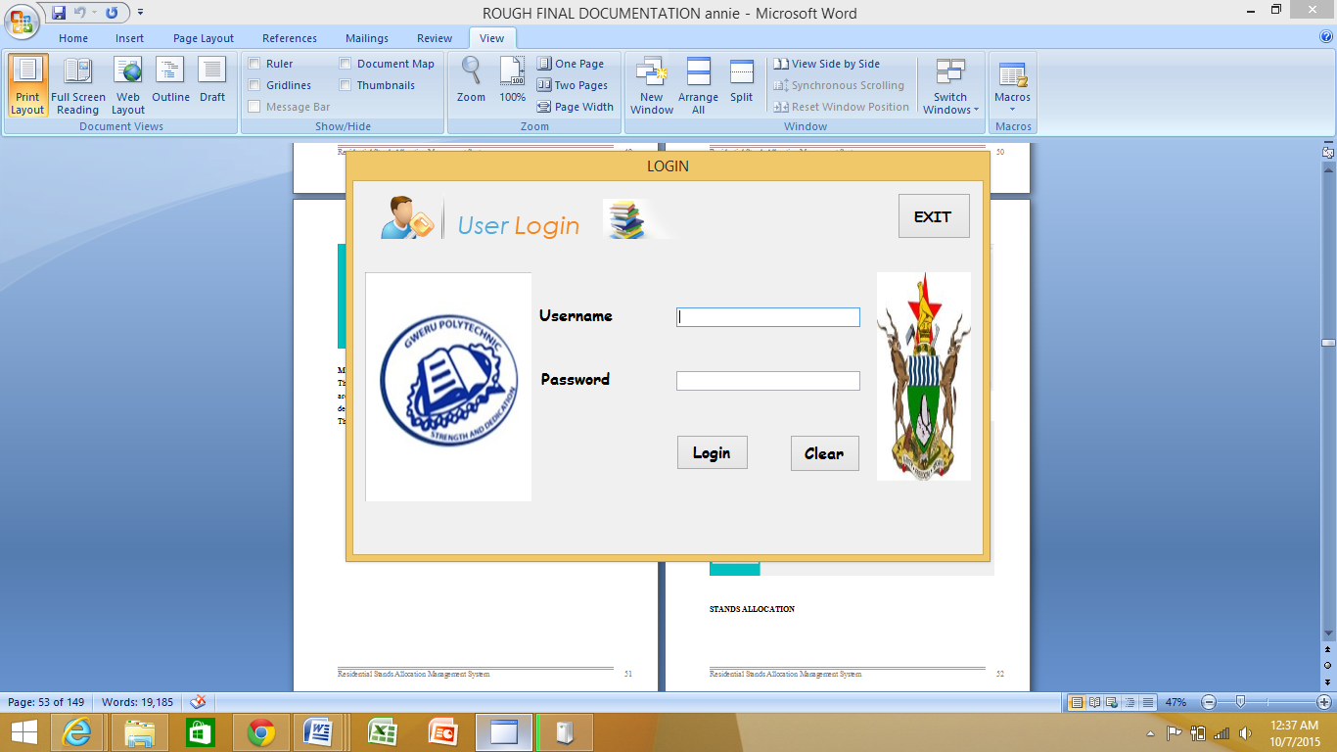

**MAIN MENU**

The main menu is displayed, which has all the options of the system on the menu bar. These are a summary, most of which are locked and only unlocked depending on the users’ department of work.

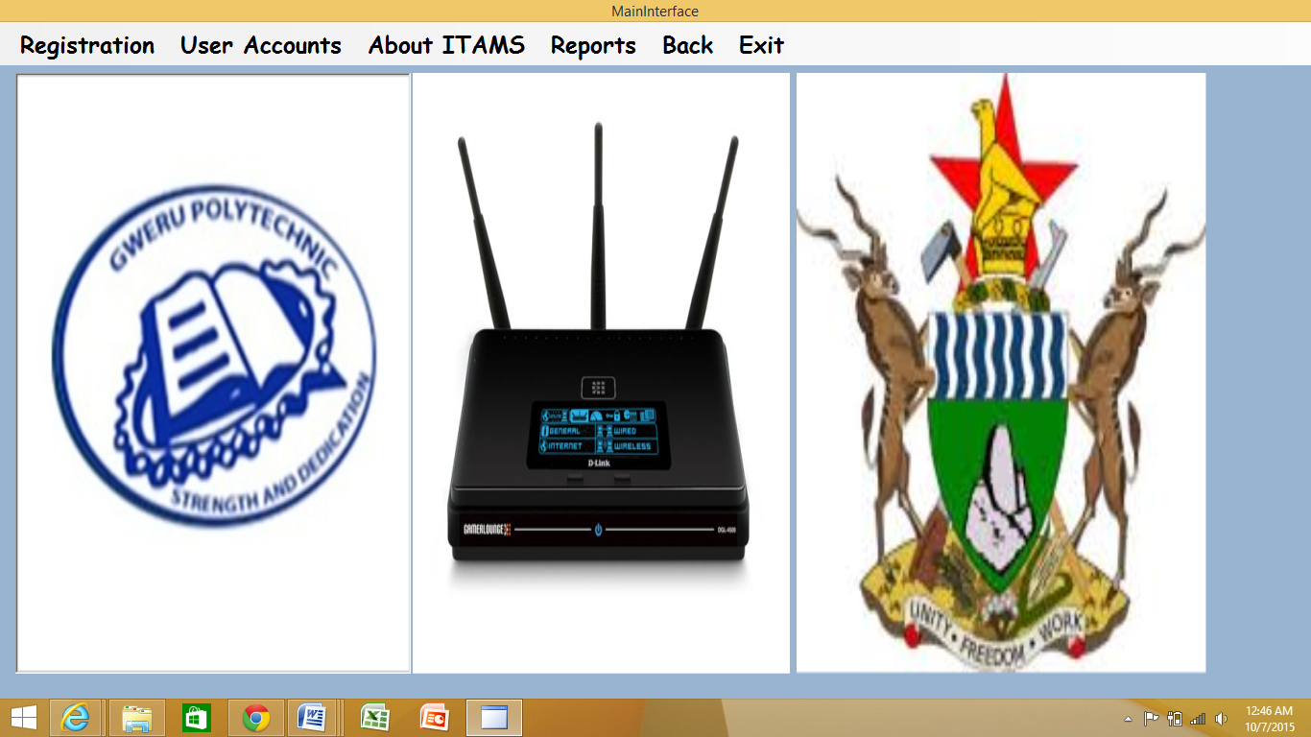

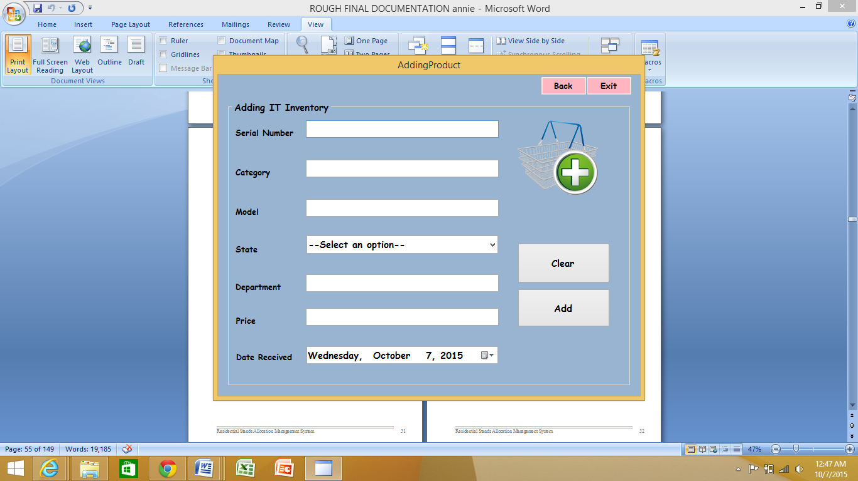

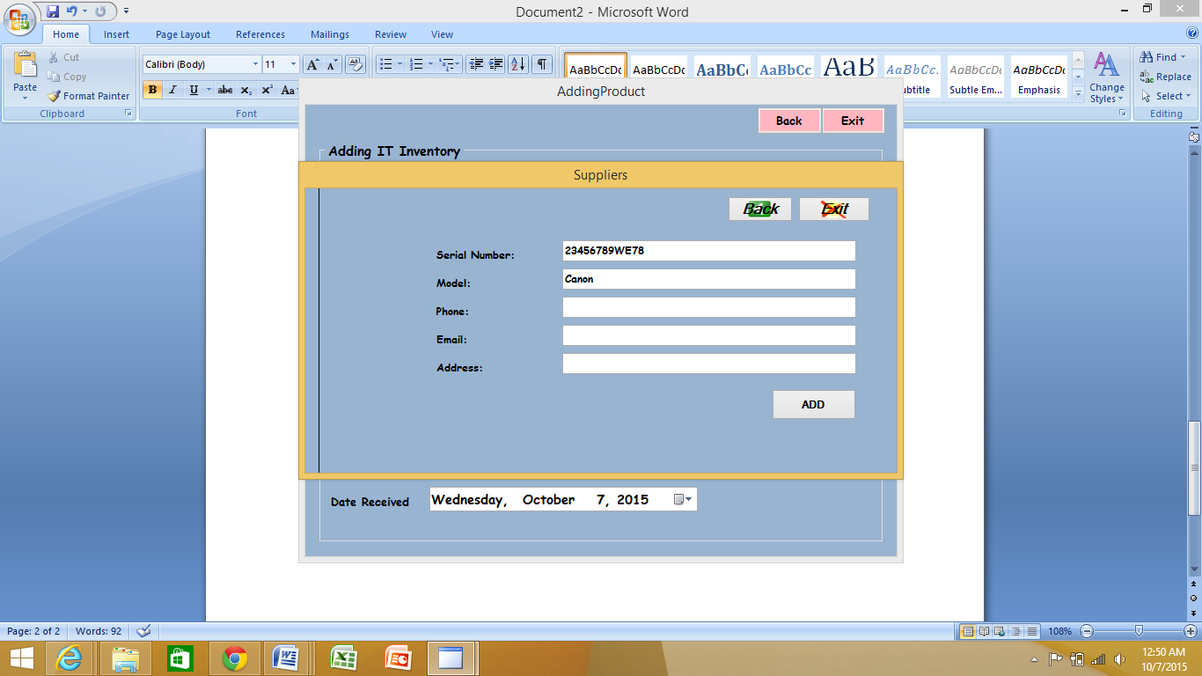

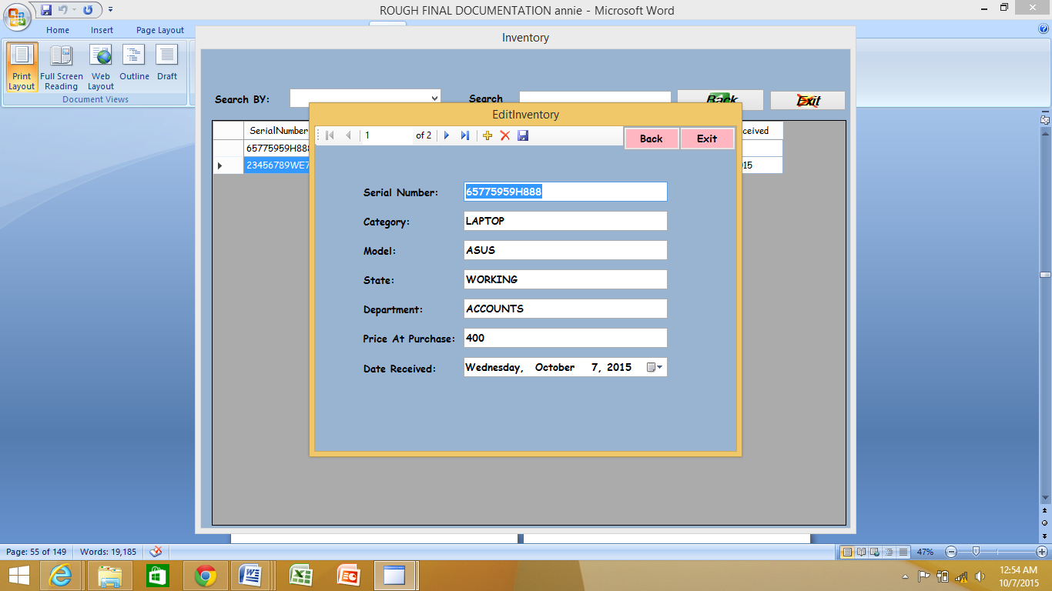

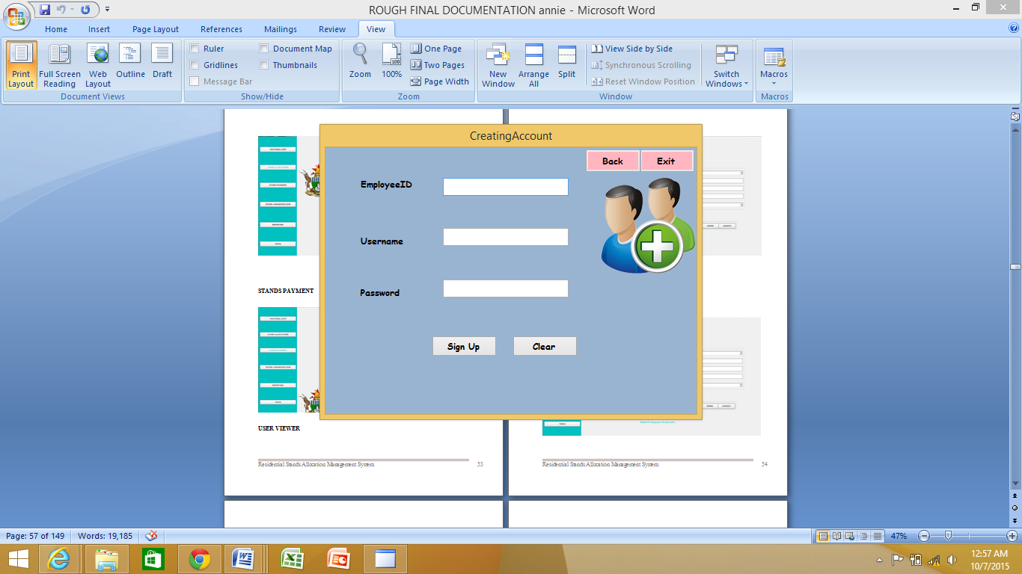

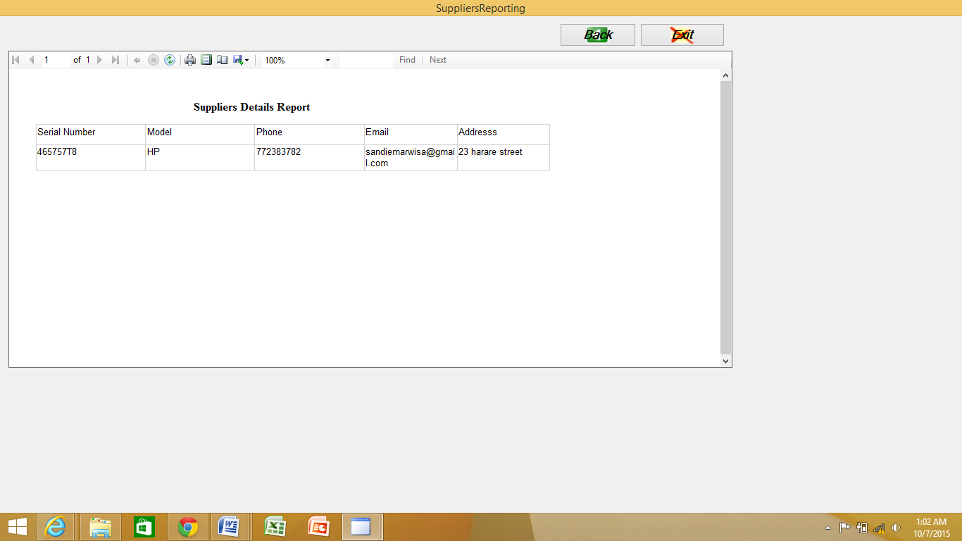

**Database design**

A database is a collection of related information organized such that efficient data processing can be carried out on the data contained in it.

The analyst is going to use a database as a central repository of data pertaining to the asset management system. This will be linked to the core system, a program to be written in Visual Studio. A database will take care of all the complex file handling and pointer manipulation that is necessary to build a fast and efficient system.

**Normalization**

This refers to the process of organizing data in relational database tables in such a way that each of the underlying fields contains atomic values. The other objective of normalization is to minimize redundancy. Normalization usually involves sub-dividing database tables into two or more tables and defining relationships between the tables. Through ensuring the atomicity of data normalization isolates data such that additions, deletions, and modifications of a field can be made in just one table and then propagated through the rest of the database via the defined relationships. The analyst will normalize the database tables to the third normal form which will result in the removal of repeating groups, partial dependencies and transitive dependencies.

**First normal form**

For a table to be in the First Normal Form it has to satisfy the following conditions:

The table has the following characteristics:

* It contains only atomic values - An atomic value is a value that cannot be divided.
* There are no repeating groups - A repeating group means that a table contains two or more columns that are closely related.

**Second normal form**

The following condition has to be meet for a table to be in the Second Normal Form:

* All non-key attributes are fully functionally dependent on the primary key.

In 2NF, non-key attributes cannot be dependent on a subset of the primary key. If the primary key is not a composite key, all non-key attributes are always fully functionally dependent on the primary key. A table that is in 1st normal form and contains only a single key as the primary key is automatically in 2nd normal form.

**Third normal form**

* There are no transitive functional dependencies

Transitive dependency refers to the existence of a case whereby a none-key attribute is dependent on one or more none-key attributes. Consider the following relationship: A is functionally dependent on B, and B is functionally dependent on C. In this case, C is transitively dependent on A via B.

Taking this into consideration, it can be noted that the database already meets the required conditions for Third Normal Form (3NF), therefore no further normalization will be required.

The following tables indicate some of the table within the system

**Users table**

|  |  |  |
| --- | --- | --- |
| **Field Name** | **Data Type** | **Description** |
| Username | Text | Name of user stored in the database |
| Password | Memo | Unique identifier of each user |
| User Level | Text | Access level or division |

**Supplier Registration**

|  |  |  |
| --- | --- | --- |
| **Field Name** | **Data Type** | **Description** |
| Product serial number | Memo | Product unique identifier |
| Model | Text | The brand name of the product |
| Email address | Memo | Email address for easy way of communication. |
| Phone number | Number | Phone number for contacting |
| Address | Memo | Address number for better improvement of communication |

5.3 DETAILED DESIGN DOCUMENTATION

**Design mechanisms**

**Psuedocode:**

* It uses a sequence of sentences, mathematical notations and a set of key words.
* Is a way to express program design using words instead of diagrams. It is easy to understand and convert to program code.
* Not restricted to any syntax.

**System flow chart:**

* These portray the sequential and logical operations to be performed by a computer while carrying out a program.
* It is prepared by using standard symbols connected by flow lines
* These are easy to comprehend
* There is normally a direct correspondence between the code and the statements.

**PROGRAM-FLOW-CHART-SYMBOLS**

|  |  |
| --- | --- |
| **SYMBOL** | **DESCRIPTION** |
|  | Denotes the flow of information from one location or process symbol to the next symbol. |
|  | Represents the input or output of data. |
|  | Shows the decision box where action is taken after the condition is taken after the condition is tested. |
|  | It is a process symbol that represents task execution. |
|  | This works as either a terminator or a starting point. |

Flow charts and pseudo code

Advantages of using flowcharts

**The benefits of flowcharts are as follows:**

* Communication: Flowcharts are better way of communicating the logic of a system to all concerned.
* Effective analysis: With the help of flowchart, problem can be analyzed in a more effective way.
* Proper documentation: Program flowcharts serve as a good program documentation, which is needed for various purposes.
* Efficient Coding: The flowcharts act as a guide or blueprint during the systems analysis and program development phase.
* Proper Debugging: The flowchart helps in debugging process.
* Efficient Program Maintenance: The maintenance of operating program becomes easy with the help of flowchart. It helps the programmer to put efforts more efficiently on that part.

Disadvantages of using flowcharts

* Complex logic: Sometimes, the program logic is quite complicated. In that case, flowchart becomes complex and clumsy.
* Alterations and Modifications: If alterations are required, the flowchart may require re-drawing completely.
* Reproduction: As the flowchart symbols cannot be typed, reproduction of flowchart becomes a problem.
* The essentials of what is done can easily be lost in the technical details of how it is done.

## SYSTEM FLOW CHART FOR ASSET MANAGEMENT SYSTEM

AO

AR

AR

AR

AR

CALL REPORTING

SUBSYSTEM

CALL UPDATING SUBSYSTEM

CALL MANAGEMENT SUBSYSTEM

OPTION = 3?

OPTION = 2?

CALL REGISTRATION SUBSYSTEM

OPTION = 1?

ENTER OPTION

**KEY**

**AR** Another Record

**AO**Another Option

NO

YES

NO

YES

NO

YES

OPTION = 3?

YES

YES

NO

YES

NO

YES

NO

YES

NO

YES

NO

## PSEUDO CODE FOR RETAIL MANAGEMENT SYSTEM

Start

Enter option

If option = 1 then

Call Registration subsystem

If Another Record = True then

Repeat Registration subsystem

Else

Stop

End If

Elseif option = 2 then

Call Management subsystem

If Another Record = True then

Repeat Management subsystem

Else

Stop

End If

Elseifoption = 3 then

Call Accounts subsystem

If Another Record = True then

Repeat Accounts subsystem

Else

Stop

End If

Elseifoption = 4 then

Call Updating subsystem

If Another Record = True then

Repeat Updating subsystem

Else

Stop

End If

Else

Call Reporting subsystem

If Another Record = True then

Repeat Reporting subsystem

Else

Stop

End If

End if

End.

1.0 PROGRAM FLOW CHART FOR REGISTRATION SUBSYSTEM

**Key**

**AR = Another Record**

YES

NO

NO

ANOTHER OPTION

NO

YES

YES

YES

YES

NO

ADD AR

ADD AR

DEPT REG

DEPT CODE

DEPT NAME

NO

NO

DEPARTMENT

CATEGORY

STATE

MODEL

SERIAL NUMBER

ENTER OPTION

YES

SUPPLIER REG

NO

YES

ADD AR

SUPPLIERNAME

PRODUCTREG

ADDRESS

PHONE

EMAIL

## 1.0 PSEUDO CODE FOR REGISTRATION SUBSYSTEM

Start

Enter option

If option=1 then

**Call Supplier Registration**

If Another record = True then

**Repeat Supplier Registration**

Else stop

ElseIf option = 2 then

**CallProduct Registration**

If Another record = True then

**Repeat Product Registration**

Else stop

Else

**Call Departmet Registration**

If Another record = True then

**Repeat Departmet Registration**

Else stop

End If

End

## 2.0 PROGRAM FLOW CHART FOR MANAGEMENT SUBSYSTEM

**KEY**

**AR** Another Record

**AO**Another Option

**NOR** New Order

**AG** Another GRV

**AT** Another Transaction

YES

YES

NO

NO

CUSTOMERCODE

ARR

CUSTOMER

MGT

ENTER OPTION

NO

YES

INVENTORY

MGT

YES

NO

NO

SALES

MGT

YES

OPTION = 1?

RETURNS

MGT

NO

YES

YES

NO

INVOICE QTY

INVOICE COST

TAX STATUS

INTERNAL ID

INVOICE NUMBER

STOCK CODE

OPTION = 1?

SUPPLIER CODE

ORDER NUMBER

TRANS

N0.

BREAKAGES QTY

COST

AR

STOCK CODE

STOCK CODE

SUPPLIER

MGT

STOCK CODE

STOCK CODE

SOLD QTY

NO

RETURNS QTY

ORDER QTY

ORDER COST

TOTAL

SALE

YES

GOODS

MGT

SUPPLIER CODE

AR

SELLING PRICE

SALE

NOR

YES

YES

NO

NO

YES

YES

AR

NO

NO

NO

MARK UP

AT

YES

AG

YES

STOCK CODE

NO

NO

AR

YES

YES

NO

AO

NO

## 2.0 PSEUDO CODE FOR MANAGEMENT SUBSYSTEM

START

Enter option

If option = 1 then

**Call Inventory Management**

If option1 = True then

Call Generate Order

If New Order = True then

Repeat Generate Order

Else Stop

Else

Call Process GRV

If Another GRV = True then

Repeat Process GRV

Else Stop

End if

ElseIf option = 2 then

**Call Sales Management**

If option1 = True then

Call Intiate Transaction

If Another Transaction = True then

Repeat Initiate Transaction

Else Stop

Else

Call Process Breakages

If Another record = True then

Repeat Process Breakages

Else StopEnd if

ElseIf option = 3 then

**Call Returns Management**

If Another Record = True then

**Repeat Returns Management**

Else Stop

ElseIf option = 4 then

**Call Supplier Management**

If Another Record = True then

**Repeat Supplier Management**

Else Stop

ElseIf option = 5 then

**Call Goods Management**

If Another Record = True then

R**epeat Goods Management**

Else Stop

ElseIfoption = 6 then

**Call Customer Management**

If Another Record = True then

**Repeat Customer Management**

Else Stop

End If

END

AR

UPDATE

CUSTOMER

UPDATE

GOODS

AR

UPDATE

SUPPLIER

UPDATE

RECEIVABLES

UPDATE

PAYABLES

AR

NO

YES

AR

UPDATE

SALES

UPDATE

BREAKAGES

ENTER OPTION

NO

NO

YES

YES

YES

UPDATING RETURNS

NO

NO

UPDATING SALES

UPDATING ACCOUNTS

UPDATING SUPPLIER

## 4.0 PROGRAM FLOW CHART FOR UPDATING SUBSYSTEM

**KEY**

**AR** Another Record

**AO**Another Option

YES

UPDATE

RETURNS

YES

UPDATING GOODS

YES

NO

NO

UPDATE

CLAIMS

UPDATING CUSTOMER

YES

AR

YES

AR

YES

NO

NO

NO

YES

NO

YES

NO

AO

YES

NO

## 4.0 PSEUDO CODE FOR UPDATING SUBSYSTEM

START

Enter option

If option = 1 then

**Call Updating Inventory**

If AR = True then

Repeat **Updating Inventory**

Else Stop

End if

ElseIf option = 2 then

**Call Updating Sales**

If Another Transaction = True then

Repeat **Updating Sales**

Else Stop

End if

ElseIf option = 3 then

**Call Updating Accounts**

If Another Record = True then

Repeat**Updating Accounts**

Else Stop

ElseIf option = 4 then

**Call Updating Returns**

If Another Record = True then

Repeat **Updating Returns**

Else Stop

End if

ElseIf option = 5

**Call Updating Supplier**

If Another Record = True then

Repeat **Updating Supplier**

Else Stop

End if

ElseIf option = 6 then

**Call Updating Goods**

If Another Record = True then

Repeat **Updating Goods**

Else Stop

End if

ElseIfoption = 7 then

**Call Updating Customer**

If Another Record = True then

Repeat **Updating Customer**

Else Stop

End if

End If

END

**KEY**

**AR** Another Record

**AO**Another Option

NO

REPORTING SALES

UPDATING ACCOUNTS

REPORTING INVENTORY

NO

NO

NO

REPORTING CUSTOMER

REPORTING GOODS

YES

YES

NO

NO

REPORTING SUPPLIER

REPORTING RETURNS

YES

YES

YES

NO

NO

ENTER OPTION

REPORT

BREAKAGES

REPORT

SALES

AR

NO

REPORT

SUPPLIER

YES

AR

YES

AR

AR

NO

YES

AR

REPORT

CLAIMS

REPORT

RETURNS

YES

YES

NO

AR

REPORT

RECEIVABLES

REPORT

PAYABLES

YES

REPORT

GOODS

REPORT

CUSTOMER

YES

AO

NO

NO

YES

YES

REPORT

PURCHASES

REPORT

STOCK

REPORT

PRICELIST

REPORT

GRVs

AR

YES

NO

NO

5.4 DESIGN METHODOLOGY

**Nassi scheneiderman chart description**

This is also known as a Nassi-Scheneidermann Flow chart which shows the logic of the main system and its subsystems. The N-S chart has a number of advantages which are as follows:

* It shows facts in a simplified way.
* It is easy to view the entire program.
* It integrates the three basic control structures used in all structured programs that are (selection, sequence and iteration)

5.5PROGRAM CODING

Programs are to be coded using Visual Studio 10.0. This programming language was selected because of its good quality interface and easy debugging of codes and error identification. The language allows modular programming and this was very helpful to the developer in that one module could be individually tested and also more than one module could be tested at the same time, thus integrated testing which saves time during the testing period. For data storage, My SQL database server was used for the system database facilities. The data is stored in tables. Any changes in the database are going to be updated as soon as the change has occurred.

Login

Source code

MAIN INTERFACE

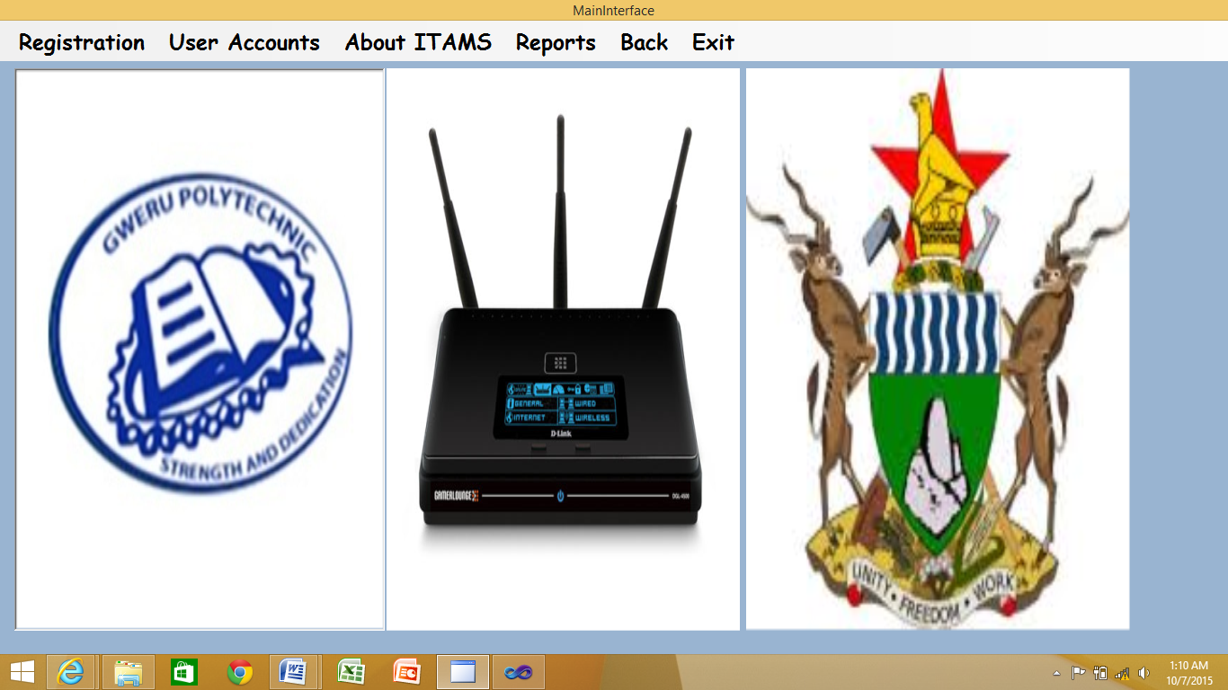

Source code

PublicClassMainInterface

PrivateSub Button1_Click(ByVal sender AsObject, ByVal e AsEventArgs)

Me.Hide()

AddingProduct.Show()

EndSub

PrivateSubHelpyButton_Click(ByVal sender AsObject, ByVal e AsEventArgs)

EndSub

PrivateSubManagingAssetsButton_Click(ByVal sender AsObject, ByVal e AsEventArgs)

Me.Hide()

Managing.Show()

EndSub

PrivateSubAboutITAMSButton_Click(ByVal sender AsObject, ByVal e AsEventArgs)

About.Show()

EndSub

PrivateSubManagingUsersButton_Click(ByVal sender AsSystem.Object, ByVal e AsSystem.EventArgs)

Me.Hide()

Sub_Menu.Show()

EndSub

PrivateSubReportsButton_Click(ByVal sender AsSystem.Object, ByVal e AsSystem.EventArgs)

Me.Hide()

LinkingReports.Show()

EndSub

PrivateSub Button2_Click(ByVal sender AsSystem.Object, ByVal e AsSystem.EventArgs)

Me.Close()

CreatingAccount.Close()

EditUsers.Close()

Login.Close()

AddingProduct.Close()

EndSub

PrivateSubBackButton_Click(ByVal sender AsSystem.Object, ByVal e AsSystem.EventArgs)

Me.Hide()

Login.Show()

Login.UsernameTextBox.Clear()

Login.PasswordTextBox.Clear()

EndSub

PrivateSubMainInterface_Load(ByVal sender AsSystem.Object, ByVal e AsSystem.EventArgs) HandlesMyBase.Load

EndSub

PrivateSubRegComboBox_SelectedIndexChanged(ByVal sender AsSystem.Object, ByVal e AsSystem.EventArgs)

Dim a AsString = Me.Text

If a = "Adding"Then

AddingProduct.Show()

ElseIf a = "Updating"Then

Sub_Menu.Show()

EndIf

EndSub

PrivateSubExitToolStripMenuItem_Click(ByVal sender AsSystem.Object, ByVal e AsSystem.EventArgs) HandlesExitToolStripMenuItem.Click

Dim result AsMsgBoxResult = MessageBox.Show("Are you sure you want to log out?", "Loging Out", MessageBoxButtons.YesNo, MessageBoxIcon.Information)

If result = MsgBoxResult.NoThen

Me.Show()

Else

Me.Close()

Login.Close()

EndIf

Cursor = Cursors.Default

EndSub

PrivateSubAboutITMSToolStripMenuItem_Click(ByVal sender AsSystem.Object, ByVal e AsSystem.EventArgs) HandlesAboutITMSToolStripMenuItem.Click

Me.Hide()

About.Show()

EndSub

PrivateSubReportsToolStripMenuItem_Click(ByVal sender AsSystem.Object, ByVal e AsSystem.EventArgs) HandlesReportsToolStripMenuItem.Click

Login.Hide()

Me.Hide()

LinkingReports.Show()

EndSub

PrivateSubBackToolStripMenuItem_Click(ByVal sender AsSystem.Object, ByVal e AsSystem.EventArgs) HandlesBackToolStripMenuItem.Click

Me.Hide()

Login.UsernameTextBox.Clear()

Login.PasswordTextBox.Clear()

Login.Show()

EndSub

PrivateSubAccountToolStripMenuItem_Click(ByVal sender AsSystem.Object, ByVal e AsSystem.EventArgs) HandlesAccountToolStripMenuItem.Click

Me.Hide()

UsersEdit.Show()

EndSub

PrivateSubAddingAssetsToolStripMenuItem_Click(ByVal sender AsSystem.Object, ByVal e AsSystem.EventArgs) HandlesAddingAssetsToolStripMenuItem.Click

Me.Hide()

AddingProduct.BackButton.Hide()

AddingProduct.Show()

EndSub

PrivateSubEditingDeletingToolStripMenuItem_Click(ByVal sender AsSystem.Object, ByVal e AsSystem.EventArgs) HandlesEditingDeletingToolStripMenuItem.Click

Me.Hide()

Managing.Show()

EndSub

PrivateSubSearchingToolStripMenuItem_Click(ByVal sender AsSystem.Object, ByVal e AsSystem.EventArgs) HandlesSearchingToolStripMenuItem.Click

Me.Hide()

Managing.Show()

EndSub

PrivateSubSuppliersToolStripMenuItem_Click(ByVal sender AsSystem.Object, ByVal e AsSystem.EventArgs) HandlesSuppliersToolStripMenuItem.Click

Me.Hide()

ViewSuppliers.Show()

EndSub

EndClass

**REGISTRATION**

**Adding a product**

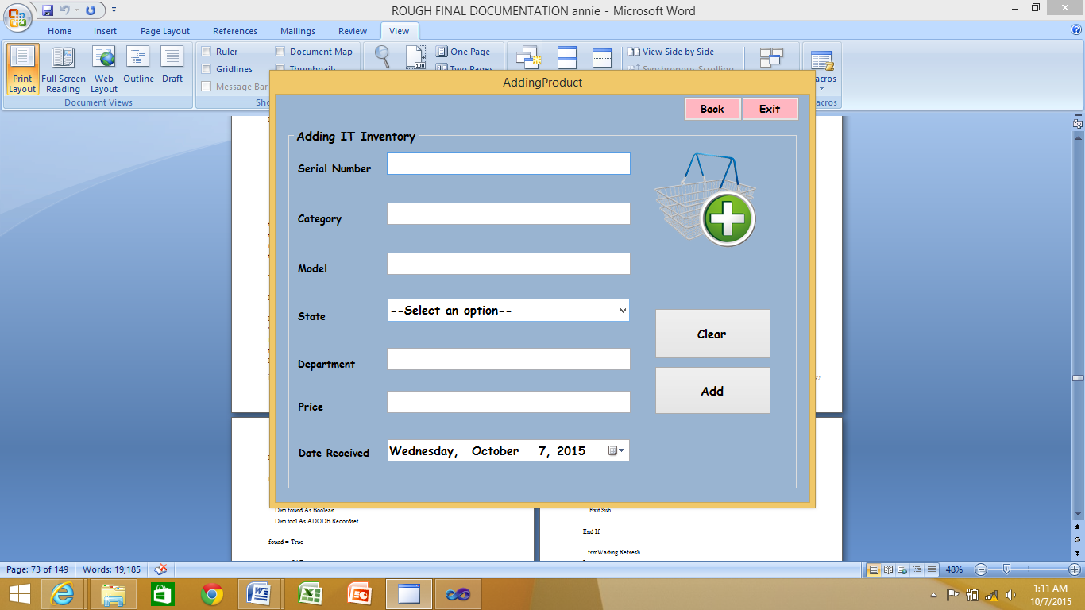

SOURCE CODE

PublicClassAddingProduct

PrivateSub Button1_Click(ByVal sender AsObject, ByVal e AsEventArgs) HandlesClearButton.Click

SerialNumberTextBox.Clear()

ModelTextBox.Clear()

CategoryTextBox.Clear()

PriceTextBox.Clear()

DepartmentTextBox.Clear()

EndSub

PrivateSubAddButton_Click(ByVal sender AsObject, ByVal e AsEventArgs) HandlesAddButton.Click

Cursor = Cursors.WaitCursor

DimdbAsNewItAssetsEntities

Dimser, cat, mode, sta, dep AsString

DimpriAsInteger

DimdatAsDate

cat = CategoryTextBox.Text

mode = ModelTextBox.Text

sta = StateComboBox.Text

dep = DepartmentTextBox.Text

Try

ser = SerialNumberTextBox.Text

Catch Ex AsException

MessageBox.Show("Serial Number Must be provided")

Cursor = Cursors.Default

Return

EndTry

Try

pri = PriceTextBox.Text

Catch Ex AsException

MessageBox.Show("Price must be a number")

Cursor = Cursors.Default

Return

EndTry

Try

dat = DateTimePicker1.Text

Catch Ex AsException

MessageBox.Show("Please select proper date format")

Cursor = Cursors.Default

Return

EndTry

DimnewProductAsNewinventory

WithnewProduct

.SerialNumber = ser

.Category = cat

.Model = mode

.State = sta

.Department = dep

.PriceAtPurchase = pri

.DateReceived = dat

EndWith

Try

db.AddToInventories(newProduct)

db.SaveChanges()

Dim result AsMsgBoxResult = MessageBox.Show("Successfull.... Do you want to add supplier details?", "RecordInserted", MessageBoxButtons.YesNo, MessageBoxIcon.Information)

If result = MsgBoxResult.NoThen

MainInterface.Show()

Me.Close()

Else

CategoryTextBox.Clear()

ModelTextBox.Clear()

DepartmentTextBox.Clear()

PriceTextBox.Clear()

Suppliers.SerialNumberTextBox.Text = ser

Suppliers.ModelTextBox.Text = mode

Suppliers.Show()

EndIf

Catch ex AsException

MessageBox.Show("Failed to save changes")

EndTry

Cursor = Cursors.Default

EndSub

PrivateSub DateTimePicker1_ValueChanged(ByVal sender AsSystem.Object, ByVal e AsSystem.EventArgs) Handles DateTimePicker1.ValueChanged

EndSub

PrivateSubBackButton_Click(ByVal sender AsSystem.Object, ByVal e AsSystem.EventArgs) HandlesBackButton.Click

Me.Hide()

OtherUser.Show()

EndSub

PrivateSub Button2_Click(ByVal sender AsSystem.Object, ByVal e AsSystem.EventArgs) Handles Button2.Click

Me.Hide()

MainInterface.Show()

EndSub

PrivateSub Button1_Click_1(ByVal sender AsSystem.Object, ByVal e AsSystem.EventArgs) Handles Button1.Click

Dim result AsMsgBoxResult = MessageBox.Show("Are you sure you want to log out?", "Loging Out", MessageBoxButtons.YesNo, MessageBoxIcon.Information)

If result = MsgBoxResult.NoThen

Me.Show()

Else

Me.Close()

Login.Close()

CreatingAccount.Close()

EditInventory.Close()

InventoryReport.Close()

LinkingReports.Close()

MainInterface.Close()

Managing.Close()

NewUser.Close()

ManagingUsers.Close()

OtherUser.Close()

OtherUserInteractive.Close()

SearchReport.Close()

Sub_Menu.Close()

Suppliers.Close()

Suppliers.Close()

SuppliersReporting.Close()

SystemUsersReport.Close()

UsersEdit.Close()

ViewSuppliers.Close()

Cursor = Cursors.WaitCursor

EndIf

Cursor = Cursors.Default

EndSub

EndClass

**SUPPLIER**

This is where we add the suppliers of our system including the model and serial number of the supplied product accompanied by supplier details.

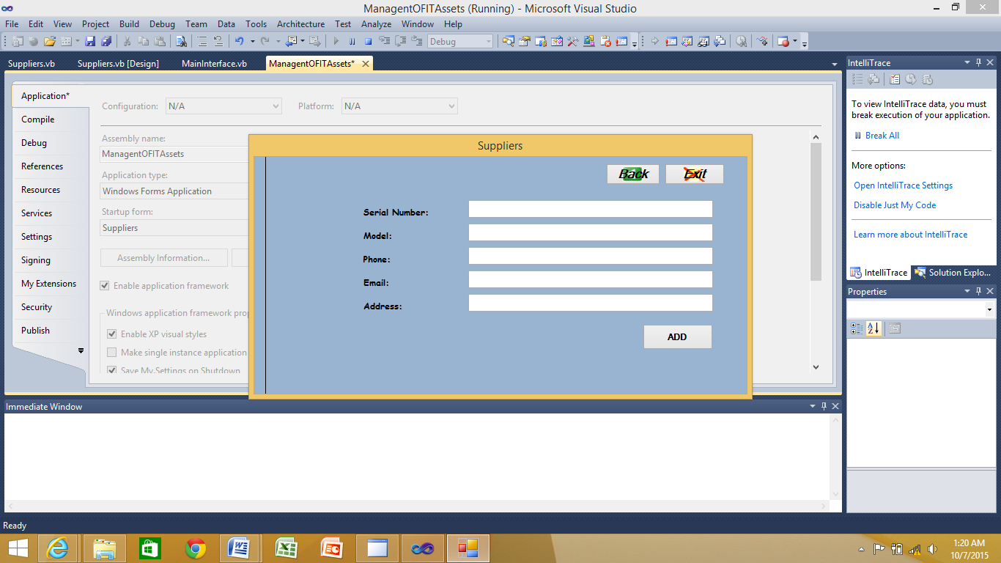

Source code

ImportsSystem.Text.RegularExpressions

PublicClassSuppliers

PrivateSubUsersBindingNavigatorSaveItem_Click(ByVal sender AsSystem.Object, ByVal e AsSystem.EventArgs)

Me.Validate()

'Me.UsersBindingSource.EndEdit()

Me.TableAdapterManager.UpdateAll(Me.ItAssetsDataSet)

EndSub

PrivateSubSuppliersBindingNavigatorSaveItem_Click(ByVal sender AsSystem.Object, ByVal e AsSystem.EventArgs)

Me.Validate()

Me.SuppliersBindingSource.EndEdit()

Me.TableAdapterManager.UpdateAll(Me.ItAssetsDataSet)

EndSub

PrivateSubSuppliers_Load(ByVal sender AsSystem.Object, ByVal e AsSystem.EventArgs) HandlesMyBase.Load

EndSub

PrivateSub Button1_Click(ByVal sender AsSystem.Object, ByVal e AsSystem.EventArgs) Handles Button1.Click

Cursor = Cursors.WaitCursor

DimdbAsNewItAssetsEntities

Dimser, mode, add, emaAsString

DimphonAsInteger

PhoneTextBox.SelectionLength = 10

mode = ModelTextBox.Text

add = AddresssTextBox.Text

ema = EmailTextBox.Text

Try

ser = SerialNumberTextBox.Text

Catch Ex AsException

MessageBox.Show("Serial number must not be duplicated")

Cursor = Cursors.Default

Return

EndTry

Try

phon = PhoneTextBox.Text

Catch Ex AsException

MessageBox.Show("Phone number must have 10 digits")

Cursor = Cursors.Default

Return

EndTry

'Try

' Dim strMessage As String = ""

' Dim regex As Regex = New Regex("([a-zA-Z0-9_\-\.]+)@((\[[0-9]{1,3}\.[0-9]{1,3}\.[0-9]{1,3}\." + ")|(([a-zA-Z0-9\-]+\.)+))([a-zA-Z]{2,4)|[0-9]{1,3}")

' Dim IsMatchAs Boolean = EmailTextBox.Text

' Dim ema As String

' If IsMatch Then

' If EmailTextBox.Text.Equals(regex.Match(EmailTextBox.Text).ToString) Then

' strMessage = "Valid Email address"

' ema = EmailTextBox.Text

' Else

' strMessage = "There is an email address somewhere. But not exactly"

' End If

' Else

' strMessage = "Sorry.invalid email address format."

' End If

' MsgBox(strMessage)

'Catch ex As Exception

'End Try

DimnewProductAsNewSupplier

WithnewProduct

.SerialNumber = ser

.Model = mode

.Phone = phon

.Email = ema

.Addresss = add

EndWith

Try

db.AddToSuppliers(newProduct)

db.SaveChanges()

Dim result AsMsgBoxResult = MessageBox.Show("Successfull.... Do you want to add another asset?", "RecordInserted", MessageBoxButtons.YesNo, MessageBoxIcon.Information)

If result = MsgBoxResult.NoThen

MainInterface.Show()

Me.Close()

Else

AddingProduct.SerialNumberTextBox.Clear()

AddingProduct.CategoryTextBox.Clear()

AddingProduct.ModelTextBox.Clear()

AddingProduct.DepartmentTextBox.Clear()

AddingProduct.PriceTextBox.Clear()

AddingProduct.Show()

Me.Close()

EndIf

Catch ex AsException

MessageBox.Show("Failed to save changes")

EndTry

Cursor = Cursors.Default

EndSub

PrivateSub Button2_Click(ByVal sender AsSystem.Object, ByVal e AsSystem.EventArgs)

Me.Close()

EndSub

PrivateSub DataGridView1_CellContentClick(ByVal sender AsSystem.Object, ByVal e AsSystem.Windows.Forms.DataGridViewCellEventArgs) Handles DataGridView1.CellContentClick

EndSub

PrivateSub Button5_Click(ByVal sender AsSystem.Object, ByVal e AsSystem.EventArgs) Handles Button5.Click

Me.Hide()

MainInterface.Show()

EndSub

PrivateSub Button6_Click(ByVal sender AsSystem.Object, ByVal e AsSystem.EventArgs) Handles Button6.Click

Me.Hide()

MainInterface.Close()

EndSub

EndClass

USERS

This form is where our system users are being created, deleted and edited and the only person who can do that is the system administrator.

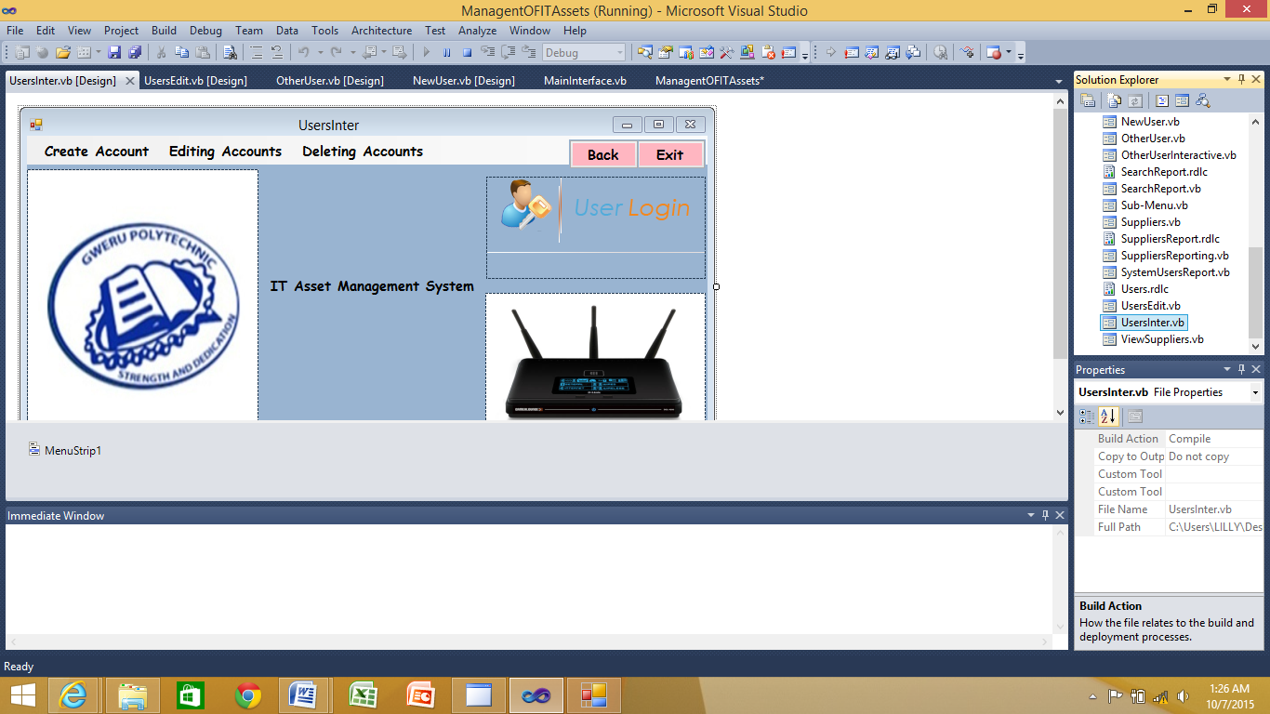

**Source code**

PublicClassUsersInter

PrivateSub Button2_Click(ByVal sender AsSystem.Object, ByVal e AsSystem.EventArgs) Handles Button2.Click

Me.Hide()

MainInterface.Show()

EndSub

PrivateSub Button1_Click(ByVal sender AsSystem.Object, ByVal e AsSystem.EventArgs) Handles Button1.Click

Dim result AsMsgBoxResult = MessageBox.Show("Are you sure you want to log out?", "Loging Out", MessageBoxButtons.YesNo, MessageBoxIcon.Information)

If result = MsgBoxResult.NoThen

Me.Show()

Else

Login.Close()

Me.Close()

EditInventory.Close()

InventoryReport.Close()

LinkingReports.Close()

MainInterface.Close()

NewUser.Close()

ManagingUsers.Close()

OtherUser.Close()

OtherUserInteractive.Close()

SearchReport.Close()

Sub_Menu.Close()

Suppliers.Close()

Suppliers.Close()

SuppliersReporting.Close()

SystemUsersReport.Close()

UsersEdit.Close()

ViewSuppliers.Close()

EndIf

EndSub

PrivateSubCreateAccountToolStripMenuItem_Click(ByVal sender AsSystem.Object, ByVal e AsSystem.EventArgs) HandlesCreateAccountToolStripMenuItem.Click

CreatingAccount.Show()

Me.Hide()

EndSub

PrivateSubEditingAccountsToolStripMenuItem_Click(ByVal sender AsSystem.Object, ByVal e AsSystem.EventArgs) HandlesEditingAccountsToolStripMenuItem.Click

EditUsers.Show()

Me.Hide()

EndSub

EndClass

5.6 PROGRAM & SYSTEM TESTING REPORT

To ensure that all aspects of the system were tested, the testing process is broken down into smaller, individual tests each targeted at an individual aspect of the system’s functionality.

* **Security Testing**

Security of a system against both internal and external elements is a very important part of every system as it ensures data integrity and authenticity which in turn ensures reliability and integrity of the system. The tests carried out include testing the system’s ability to detect and restrict attempted access to the system or data by unauthorized personnel. It also involves testing the system’s ability to prevent data theft and/or data tempering. It is undeniable that someone with enough determination and know-how might be able to gain unauthorized access to the system hence it is imperative to make this process a difficult experience.

* **Usability Testing**

This involves testing the ease with which users can understand and interact with the system’s interfaces. It tests whether the system is user-friendly or not. It is a black box testing technique which also tells whether the users feel comfortable with the system by assessing such issues as flow, navigation and layout, speed and content - especially in comparison to prior or similar applications. Usability testing tests the following features of the system.

* How easy it is to use the system ?
* How easy it is to learn the system?
* How convenient is the software to end user?

Usability testing includes the following five components:

1. **Learnability :-**How easy is it for users to accomplish basic tasks the first time they encounter the system?
2. **Efficiency :-** How fast can experienced and inexperienced users alike accomplish basic tasks?
3. **Memorability :-** When users return to the design after a period of not using it, do they remember enough to use it effectively the next time, or do they have to start learning everything over again ?
4. **Errors :-** How often do users make errors, how severe these errors are and how easily can they recover from the errors?
5. **Satisfaction :-** How much do the users like using the system?

* **Performance testing**

As the name suggests, this involves testing certain aspects of the performance of the system. These include the size of the application on the hard disk drive when installed, the amount of ram it requires, resources required, processing and response time when running under normal conditions.

* **Stress Testing**

This is a type of non-functional testing method which involves testing the system beyond normal operational capacity, often to a breaking point, in order to observe the results and determine the stability of the system. It emphasizes on robustness, availability, and error handling under a heavy load, rather than on what would be considered correct behavior under normal circumstances. The main objective of stress testing is to ensure that the system will maintain stability and not crash in conditions of insufficient computational resources such as memory or disk space.

* **Recovery Testing**

Involves testing the system’s ability to recover from faults/mulfunctions and errors by deliberately interrupting the system in various ways, such as taking its hard disk drive offline, terminating the application while in the middle of processing a transaction or even switching off the computer, to ensure that the system can recover from these errors without losing data and maintaining data consistency.

**Testing Procedures**

**Validation**

Validation testing seeks to ensure that the system conforms to the organization’s requirements, objectives and users’ expectations. It addresses issues such as “Are we building the right software?”, “Are we accessing the right data (in terms of the data required to satisfy the requirements)?”. Validation testing requires a working product against established criteria ensuring that the product integrates correctly into the environment.

Validation testing also overlaps to a large extent with system testing, where the application is tested with respect to its typical working environment. Consequently for many processes no clear division between validation and system testing can be made. .

The system will validate data as it is entered into the system by performing the following checks:

* **Format checks: -** only permissible characters in the appropriate fields.
* **Completeness checks: -** ensures that all the data required is present before any processing can be done.
* **Compatibility checks: -** relates contents of one field with another.
* **Existence checks: -** the entire necessary fields are filled with data.

**Verification**

It is also known as data accuracy test. Before data is entered in the system for processing and/or storage, it has to be transcribed from source documents onto a computer input medium. The input of data into the system is a process that is prone to human errors particularly where large volumes of data are involved. Verification is done to ensure accuracy of the data entered into the system.

**Diagram of Testing Procedures**

**VALIDATION**

**VERIFICATIOnN**

**SYSTEM DATA**

**Testing Process**

The testing process was conducted based on Software Engineering principles and practices such as the Clean room Software Engineering. This is an approach to software development that emphasizes on defect prevention. This approach involves numerous methods of testing so that the system could meet the user specifications. The following testing methods were used;

* Unit Testing.
* Module Testing.
* Sub-System Testing.
* System Testing.
* Acceptance Testing.

**Unit Testing:**

This involves the breaking down of the system into individual units which are then tested individually and independently without the other system components. It tests single program statements. The objective of unit testing is to identify and rectify the execution errors and any existing logical errors. By breaking down the system into smaller units, the identification of errors is made easier and so is the debugging process.

**Module Testing:**

A module is a collection of program statements that depended on each other (modular cohesion). Individual modules can be tested without other system modules for example in our case individual forms were tested separately to verify that they performed as desired.

Involves collection of independent components e.g. procedures and functions are tested without other system modules.

**Sub-System Testing:**

Involves detection of inter-surface mismatches and rigorous exercise of interfaces were carried out. It involved testing two or more modules working together to ensure that they were performing according to specifications. This ensures that the job streams are correct and requires the analyst to test whether there is integration of interfaces in the different parts of the system. Units that passed unit testing were combined to see if the modules were functioning together as expected.

**System Testing:**

The system was converted into an executable file and we tested to see if the system performed the required functions. The system was able to retrieve records from the database, add records to the database, deliver reports and execute queries.

**Acceptance Testing:**

This was the final test in a series of tests before the system

After the system test has corrected the defects and errors, the system is delivered to the users for acceptance testing. This is basically done by the users although other stakeholders may be involved as well. The goal of acceptance testing is to establish confidence in the system and it is most often focused on a validation type testing. There are various types of acceptance testing, namely:

* **The User Acceptance test**: focuses mainly on the functionality thereby validating the fitness-for-use of the system by the business user. The user acceptance test is performed by the users and application managers.
* **Operational Acceptance test:** also known as Production acceptance test validates whether the system meets the requirements for operation. In most of the organization the operational acceptance test is performed by the system administration before the system is released. The operational acceptance test may include testing of backup/restore, disaster recovery, maintenance tasks and periodic check of security vulnerabilities.
* **ComplianceAcceptance testing:** It is also known as regulation acceptance testing is performed against the regulations which must be adhered to, such as governmental, legal or safety regulations.

**CONCLUSION**

With the system design complete, the new system can now be implemented and tested to see if it is addressing the specifications outlined in the analysis phase. The designing phase helped in identifying and arranging the program modules so as to come up with the best system interfaces, data storage structures and the output formats. The program coding stage marked the end of the designing phase and the beginning of the Implementation Phase, which will begin by designing the implementation and testing strategies.

6. IMPLEMENTATION REPORT

6.1. User training schedule and content

The main objective of System Implementation is to make available the new system to the users. Its processes include conversion from the old system to the new system as well as maintaining the new system. Upon deployment of the system, all users must be made aware of all the steps in executing the system

6.1.2 Conversion plan and procedures

This refers to the actual technical process of converting from the use of the old system to the new one. This process however requires great care and precision to ensure that the changeover process goes smoothly without disrupting the operations of the organization. A number of methods can be employed to achieve the desired smooth transition and it is only a matter of choosing one that suits the organisation’s environment. Implementation procedures can be done in two methods, that is:

**Parallel Method**

This is when the new system is used concurrently with the old system, whereby elements of the old system are continually being replaced by the new system so that at the end there is full conversion. This ideal is effective as it provides the user with hands-on skill and gives the user much learning space.

**Advantages**

* Pilot conversion also allows for the new system to be tested with real-world data as a complete system.
* If the new system fails, the old system continues with a minimal loss of data

**Disadvantages**

* If a system undergoing pilot conversion does fail, the data in the new system is lost.
* It can also lead to some confusion as to which system is being used for what

**Direct Conversion**

This is a direct approach whereby the old system is discarded and replaced by the new system. The direct changeover approach causes the changeover from the old system to the new system to occur immediately when the new system becomes operational. It is the least expensive but is also the riskiest option as it poses a high risk of data loss because the organizationcannot revert to the old system as a backup option in case the new system malfunctions. The costs of implementation are relatively low because one system is in operation.

**Advantages**

* The new system is available for use to everyone immediately
* Is the cheapest method of implementation as there is only one system working.
* Reduced data duplication

**Disadvantages**

* Riskiest method because if something goes wrong with the new system, there is nothing to fall back on. This means disruption of operations until the problem is rectified.
* Requires transfer all of the data to the new system before the old one can be discarded.
* No system is available during the changeover period as the new system cannot be implemented while the old one is still running.

**Recommended Course of Action**

After a thorough analysis of the above mentioned conversion methods, the analyst would highly recommend the use of the parallel conversion method for the following reasons :

* The method gives the end user enough time to verify the efficiency and the effectiveness of the new system.
* It offers users the security of a backup
* Risk is relatively low because results can be verified and a backup option exits.
* Users have ample time to familiarize themselves and adapt to the system.
* If problems occur with the new system the old system is available for continued use.
* It will not be all that costly as the new system is partially manual thereby encompasses certain aspects of the old system.

6.1.3 POST IMPLEMENTATION PLAN

This phase of the project development is very sensitive and a busy stage. This is the time when the system is physically implemented. The system is to be implemented using parallel conversion that is the two systems will be run concurrently, the existing system and the new system until the system is fully comprehended.

**The following software needs to be installed before the new system is loaded:**

* Windows 7 operating system
* Database Package
* Microsoft Visual Studio 2010

6.2. USER MANUAL

# This is a tool used to inform users of how they can use the system. It provides a platform on which users can theoretically interact with the system before they can have a hands-on. The user manual has been designed to make available to the user the available forms and sub-processes on which the user can implement in the system. It is also a reference to the user when he/she has forgotten to manipulate some procedures. Forms have been documented and descriptions or steps to manipulate the processes have been written below.

* Insert disk into disk drive.
* Copy the folder named lilly project into C:drive
* Send a shortcut of the following file management.exe to the desktop
* Run the system using this shortcut.

**Interface design**

The interface with respect to the system and its users deals with the link or surface or interaction between the system and its users. It thus provides a mode of communication between the two entities.

**User Interface**

**GUI** is favorable to a **Command Driven Interface** because the screens resulting are more interactive to the end user hence more user friendly, commands will be there on screen embedded in click buttons and menu options, as opposed to a scenario where the user should remember them in a command driven interface. Screens resulting from the chosen interface are more colorful, attractive and methods of operation can be made just like any other Windows Application so learning the system will only be a natural progression from the common.

The objective of this stage is to develop, design and implement quality user interfaces, that is, an interface that is easy to use and allows the user to maximize efficiency and effectiveness when using them. Each form will carry a heading that specifies the function of the form.

6.2.1 ABOUT THE SYSTEM

Log in form



# To get into the system the user has to type the correct username and password as assigned to him/her by the administrator. The following are usernames and passwords that have been assigned to the users:

**Username admin**

**Password 2015**

**This Logon form is the interface on which the user is able to enter into the system. The user has to enter his/her Username upon which he/she then enters the Password. Upon clicking login this automatically allows the user to get into the system and be able to use it**

**TO REGISTER A PRODUCT**

**Products are being added here showing their serial number, category, model, state, price and department of departure.**

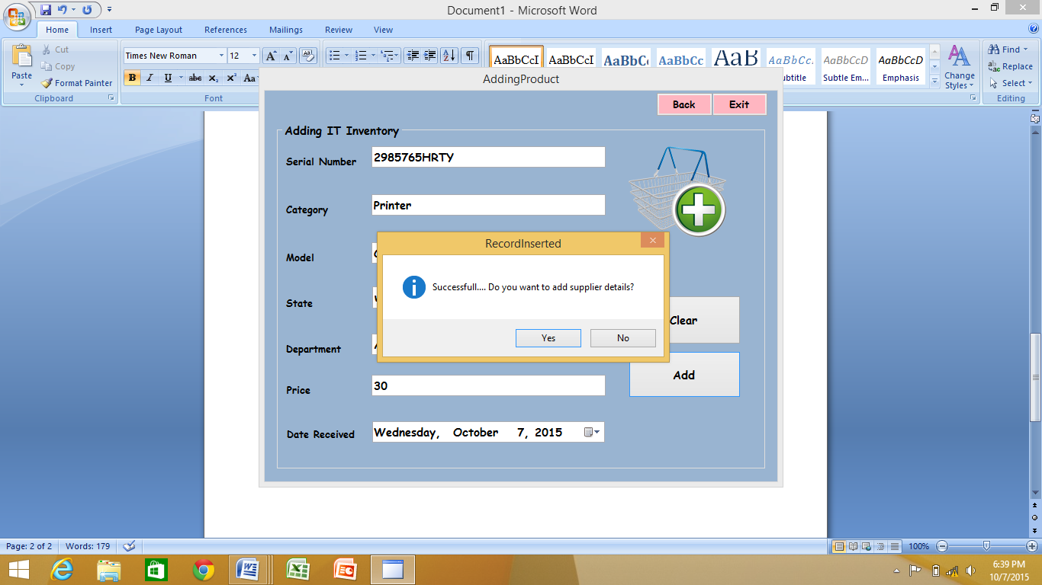

**ADDING SUPPLIERS**

**Supplier detailes are captured using this form and the information which is being captured is the model and serial numbers of the supplied produs and supplier details.**

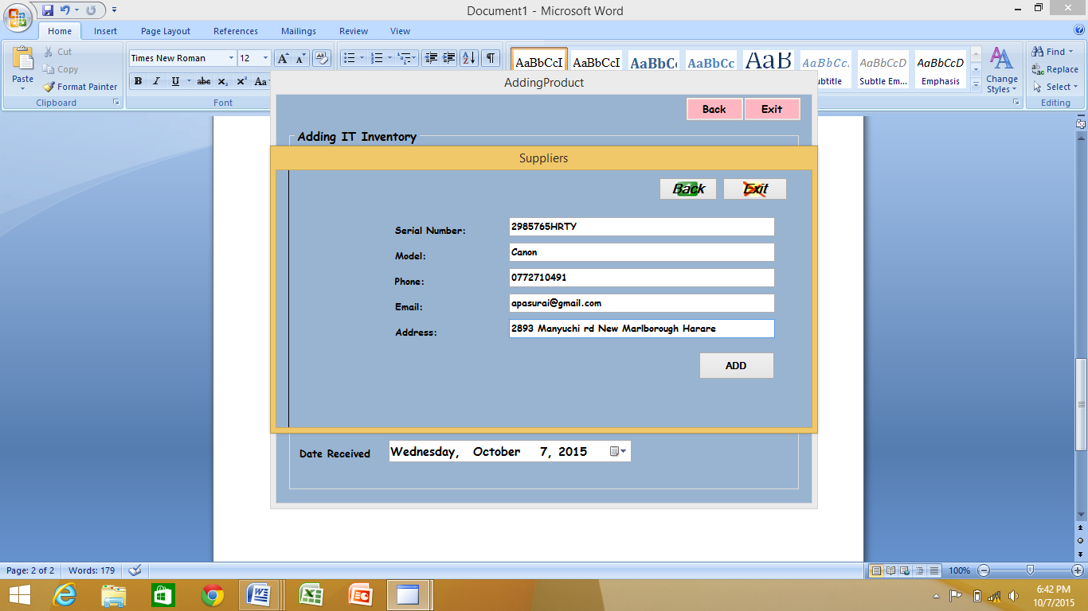

**CREATING USERS**

**Only the admin has the priviledge of adding and removing users from the system upon verifying hs or her credintials.**

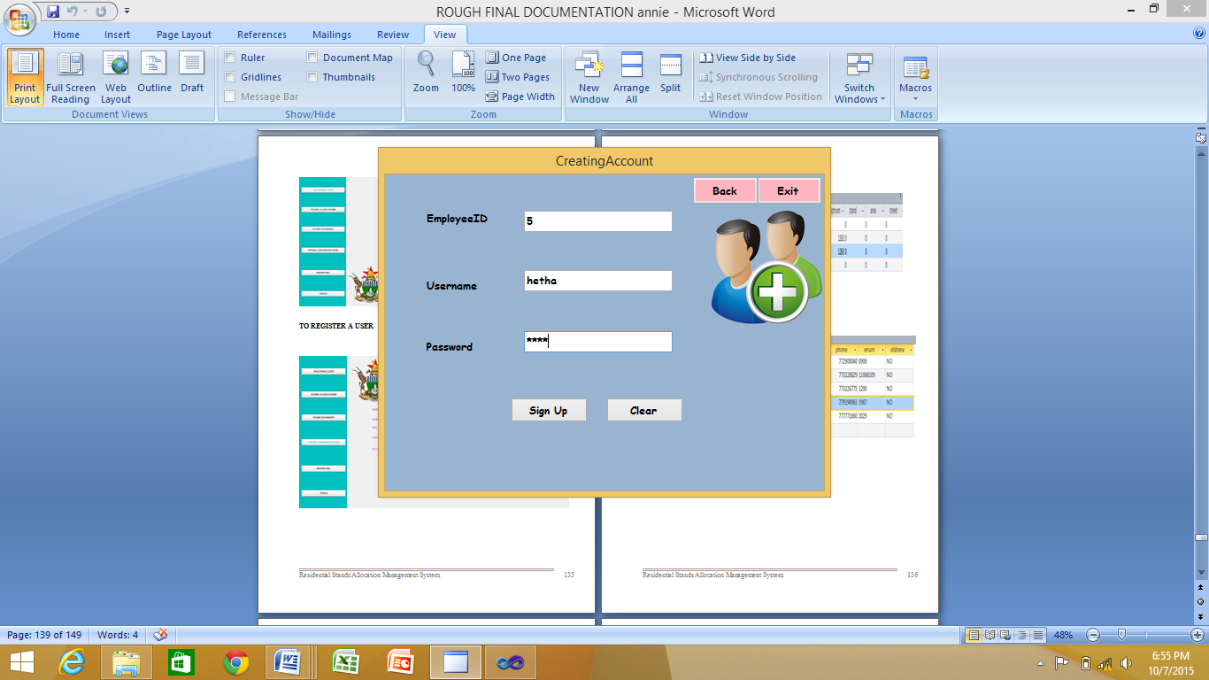

**DATABASE DESIGN**

**Below is an overview of the database in use.**

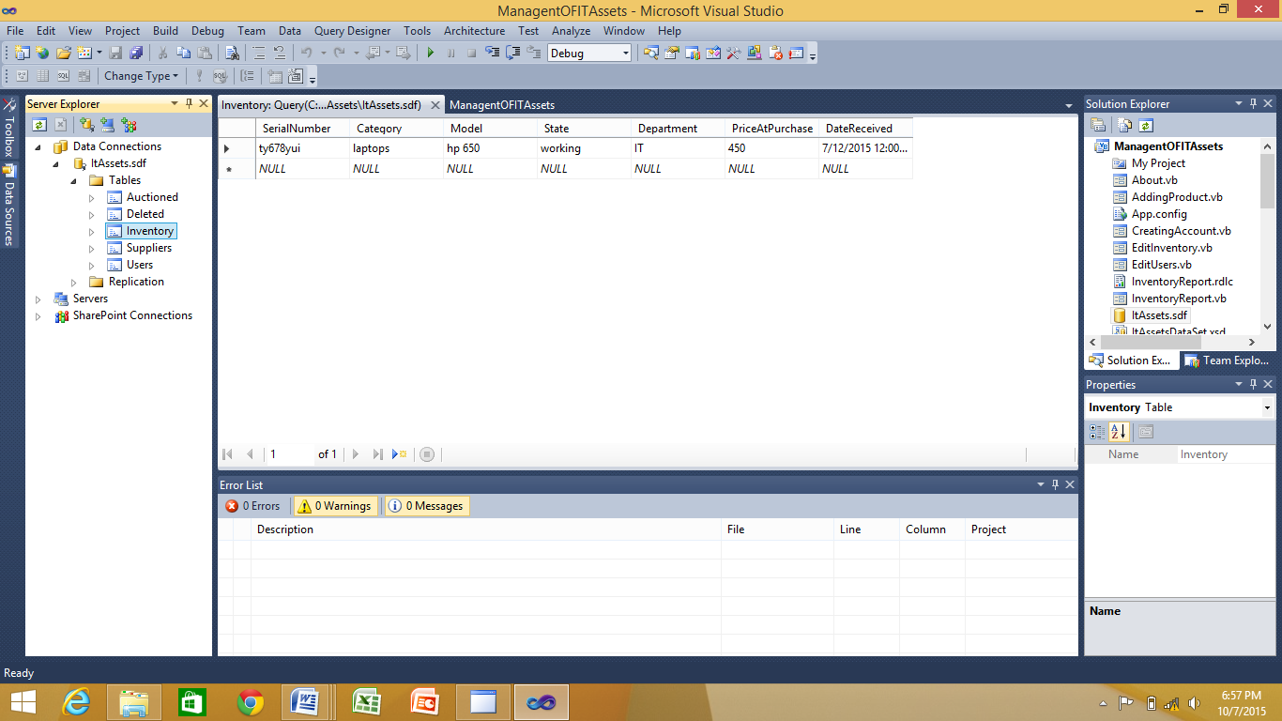

**6.2.2. HOW TO USE PROGRAMS AND SUBPROGRAMS**

**LOGIN**

The login form requests the user to select his or her username and enter the corresponding password. This menu was designed so as to secure the system as well as integrity rules to the system, hence minimizing the entry of unauthorized user to get access to the system.



In case the user enters the wrong password, the system displays the following information.

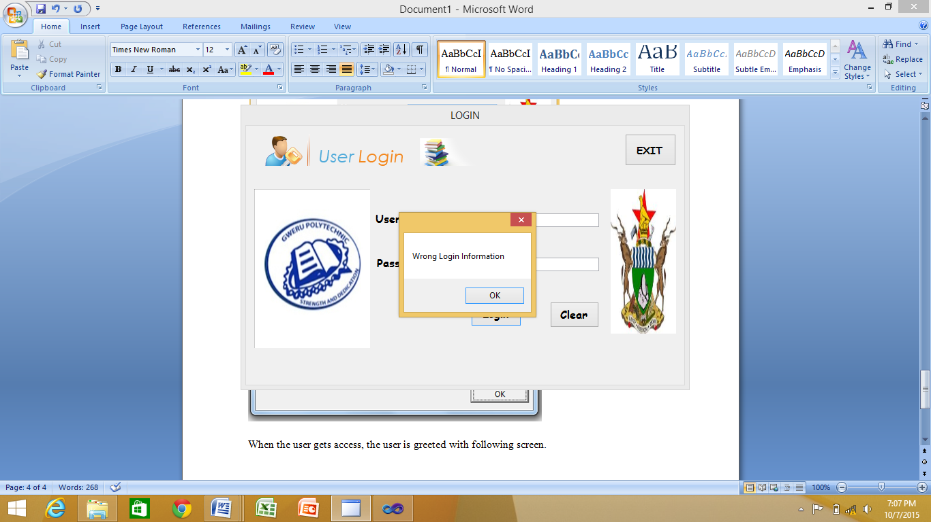

When the user gets access, the main menu is displayed which give access to user based on access level allocated to him on user registration.



From the main menu form the user can then go on to manipulate the forms they have access. If they no longer wish to continue they can then exit this form by clicking the back button and the form will close and lead back to the log in form or exit and the system will close completely.

**REGISTRATION**

When the user clicks the registration option the screen overleaf shows the following options:

* Adding Assets
* Editing/deleting
* Searching
* Suppliers

The adding option leads to the form responsible for entering new product details into the system.

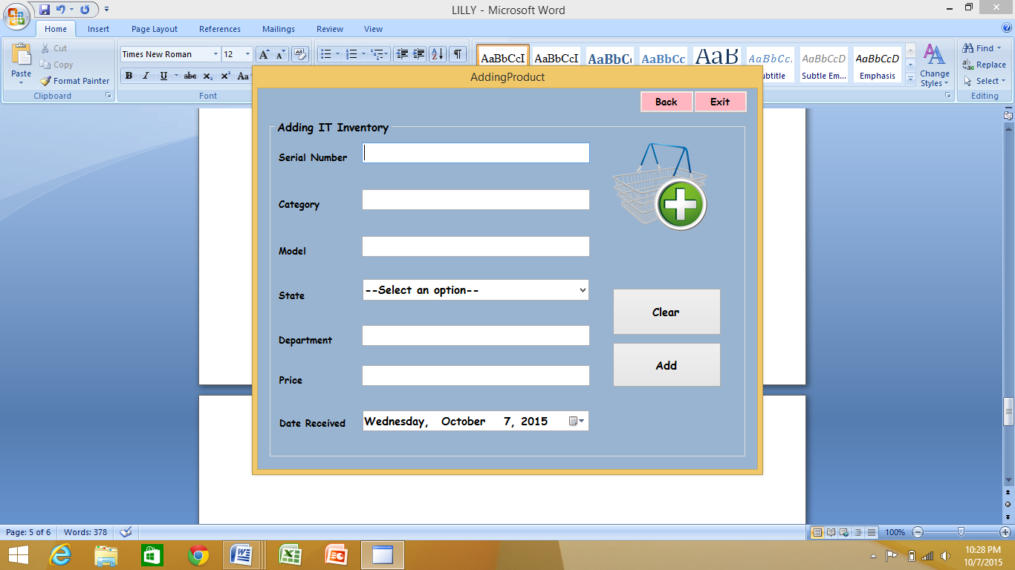

The deleting/editing option leads to the form responsible for modifying data items in the system.

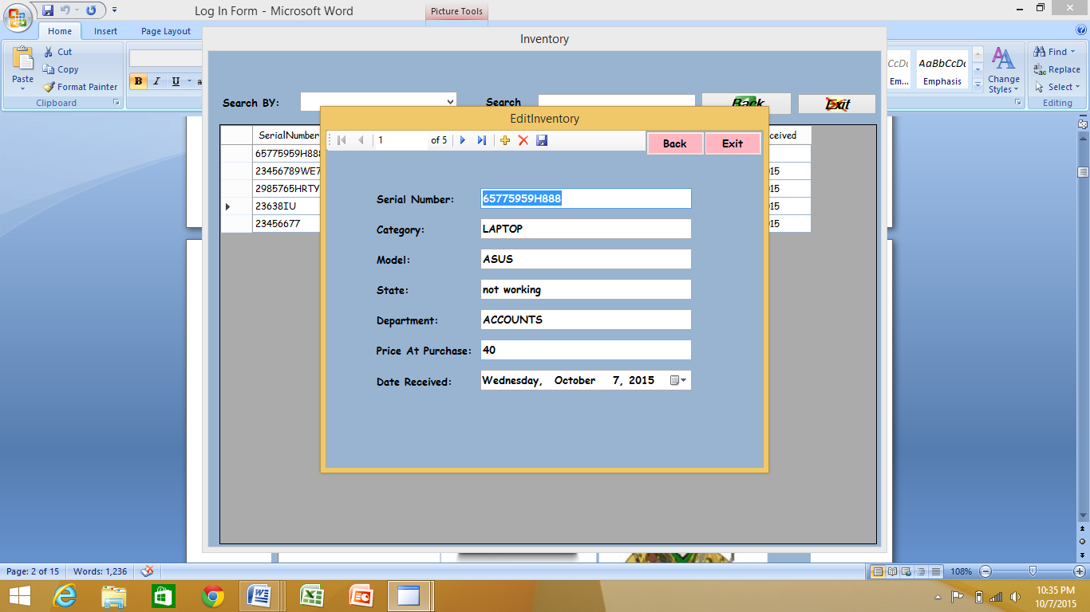

The supplier option leads to the form responsible for adding suppliers into the system.



**USERS**

While on the main menu form, click on User Accounts then you will have to confirm that you are the system administrator by providing admin username and password.

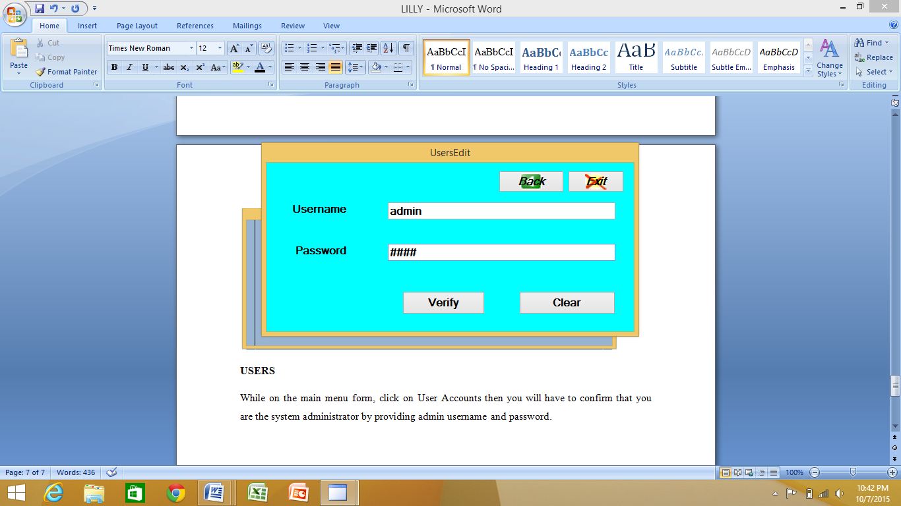

After verifying that you are the admin you are then allowed to proceed to the following form which allows the creation and modification of users.

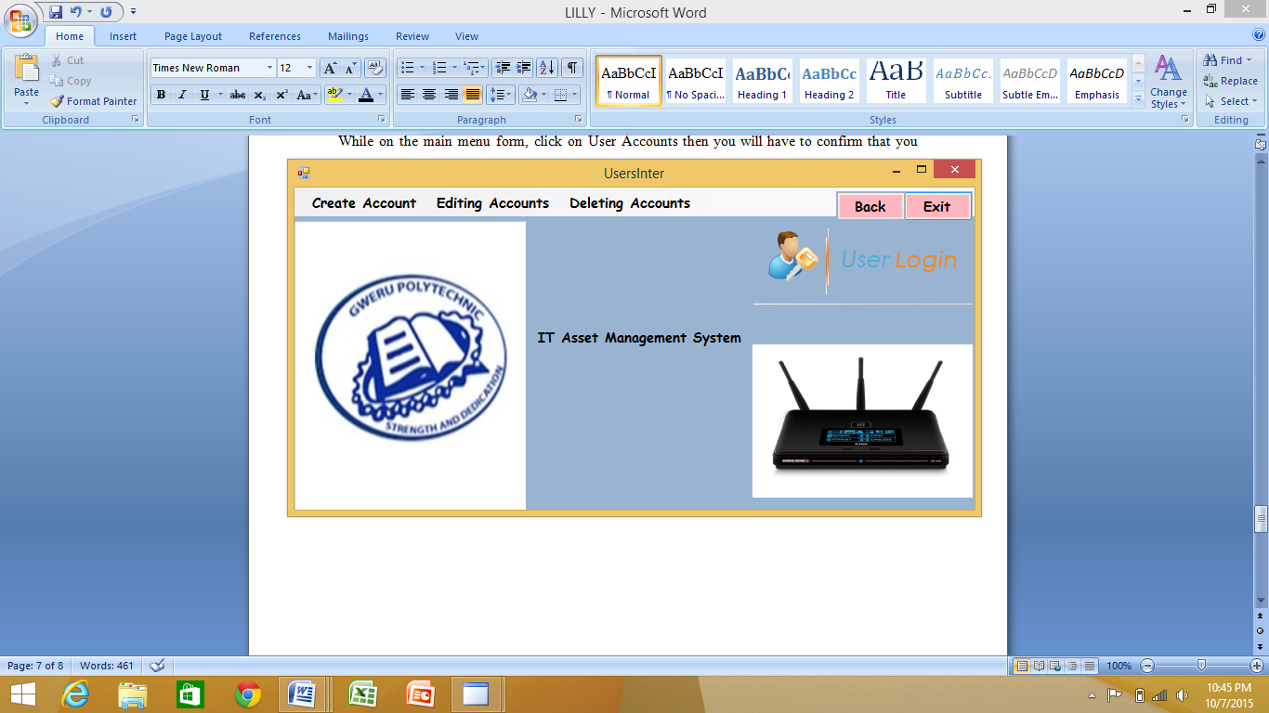

**REPORTING**

Click the report button on the main menu form and it shows a list of all the reports within the whole system.

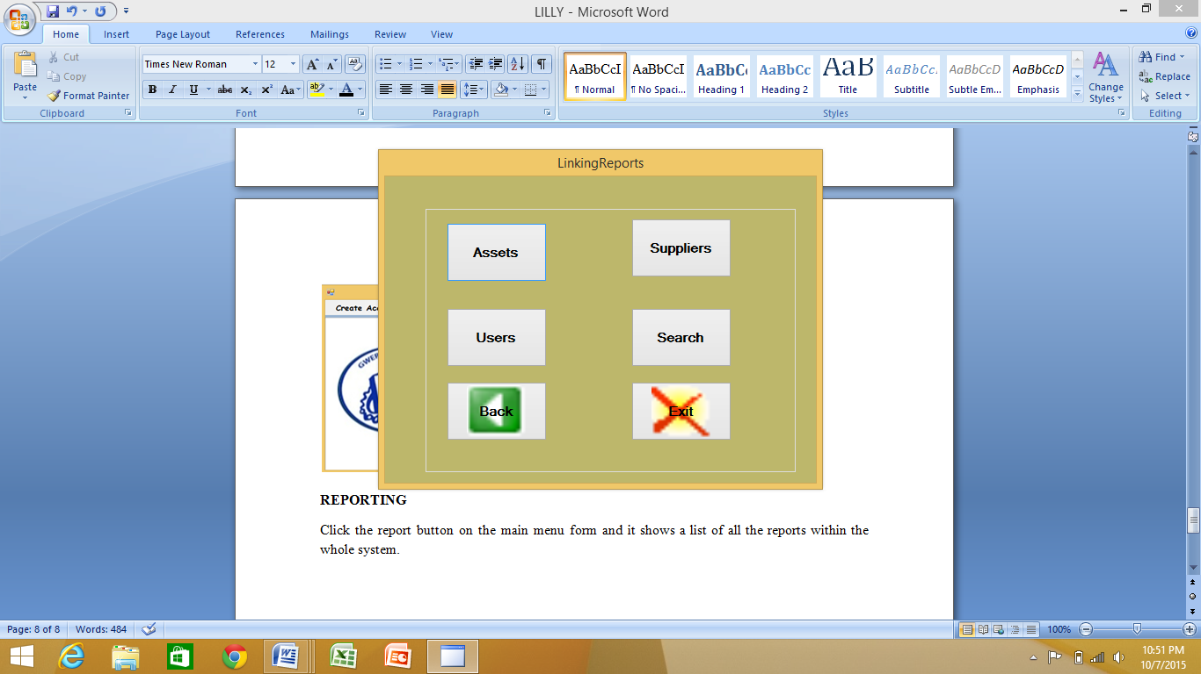

**EXIT**

Click the exit option and will exit the system completely to the log in form



**CONCLUSION**

The system was produced out of hard work and research, it is my desire that software designers may not procrastinate in advancing Information Technology in Zimbabwe. Special thanks to my brother who stood by me in all times Stanley and all those who contributed in making this project a success, I stand to be grateful. All honour is granted to the most high and powerful God shouting Ebenezer that is far the Lord has taken me.